#10 LINEAR-QUADRATIC SYSTEMS
Example 1: Holy Carp!
Silver carp, a species of Asian carp, have the ability to leap from underwater to several feet in the air! The freshwater fish get scared by predators and machines such as boat motors, so they protect themselves by hurling themselves up to 10 feet above the water’s surface. They’ve been known to cause injuries to boaters and fishermen by hitting people in the head, neck, and back! Silver carp were brought, illegally, to the Great Lakes in 1973 and have made their way down to the Illinois and Mississippi rivers.
In this example, a silver carp jumps out of the water. Its height can be modeled by the equation h = -16t² + 26t – 2 where h represents the height of the fish in feet after t seconds. A hawk sees the fish and flies down to catch the carp in mid-air. The height of the hawk can be modeled by the equation h = -12t + 20.
Graph the equations for the heights of the carp and hawk, and use your graph to answer the questions.
Height (ft.)
- After how many seconds does the hawk catch the carp?

- What is the height of the hawk and carp when they meet?

- Let’s say that the hawk misses grabbing the carp on their first encounter. About when will the hawk have a second chance to graph the carp?
Time (s)

TWO SOLUTIONS ONE SOLUTION NO SOLUTIONS
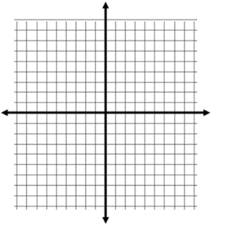
EXAMPLE 2: SOLVING ALGEBRAICALLY
y = x² - 6x + 5
y - 2x = 5

EXAMPLE 3: SOLVING GRAPHICALLY y = 2x² + 3x – 5
(refer to handout) y = $\frac{2}{3}$x + 4
YOU TRY! In partners, practice applying linear-quadratic systems to the real world by solving the following: A silver carp jumps out of the water in Lake Michigan. Its height can be modeled by the quadratic equation h = -16t² + 24t – 1 where h represents the height of the fish in feet after t seconds. The height of a fisherwoman sitting in a boat can be modeled by the equation h = 7.
Graph the equations for the heights of the carp and fisherwoman on the graph provided. Use your graph to answer the questions below. Be sure to label each axis on your graph.
- The carp jumps out of the water (from behind the boat) and hits the fisherwoman on the head! After how many seconds does this happen?

- What is the height of the fisherwoman and carp when they collide?

- Let’s say that the fisherwoman leans to the side and misses getting hit by the carp just in time. When will the carp have a second chance to hit the woman in the boat if it doesn’t change direction?

