Unit 7 #1 Equations of Circles
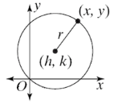
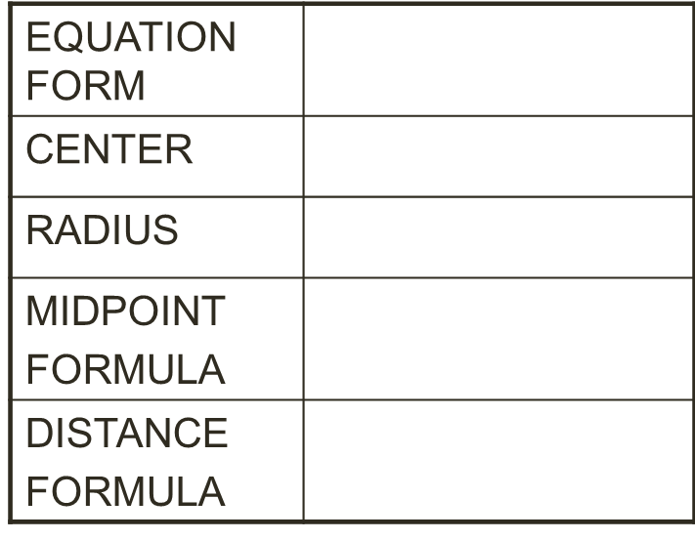

Key Information
The center of the circle: __________________________
The radius of the circle: __________________________ Any point on the circle: __________________________
r is the radius of the circle so if we take the square root of the right hand side, we'll know how big the radius is.
The equation of the circle: ________________________

Writing Equations of Circles:
Center | Radius | Equation
(4,7) | 5
(-3, 8) | 6.2
(2, -9) | $$\sqrt{11}$$
(0, 6) | $$\sqrt{7}$$
(-1.9, 8.7) | 3

Error Analysis: A student says that the center of a circle with equation: (x – 2)² + (y + 3) ² = 16 is (-2, 3). What is the student’s error? How should the equation be written in order for the student to be correct?

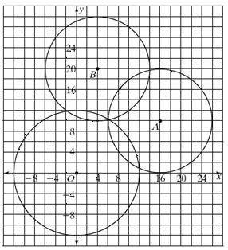
FINDING AN EQUATION OF A CIRCLE
1. Circle A
center: ______________________________
radius: ______________________________
equation: ____________________________

2. Circle B
center: ______________________________
radius: ______________________________
equation: ____________________________

3. Circle O
center: ______________________________
radius: ______________________________
equation: ____________________________

GRAPHING CIRCLES
Let's look at the equation: 1: (x – 3)² + (y – 2)² = 9
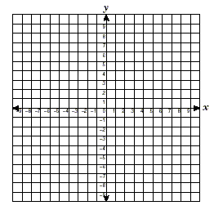
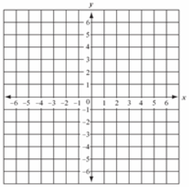
center:____________
radius:____________

2: (x – 5)² + y² = 36 3. (x + 4)² + (y – 1)² = 25
center:______________________ center:______________________
radius: ______________________ radius: ______________________

Application Problem: Suppose you know the endpoints of a circle. How do you determine the equation of the circle, if you don’t know the radius or center? Endpoints at: ______________________
FIND THE CENTER: EQUATION: _________________________

FIND THE RADIUS:

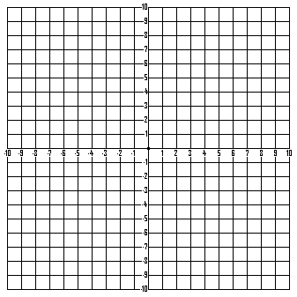
Practice Problem: Find the center, the radius, and write the equation for the circle whose diameter has endpoints at (2, 6) and (5, 12).
Center: _____________
Radius: _____________
Equation: ________________________

