Unit 8 #1 Theoretical & Experimental Probability

What is probability?
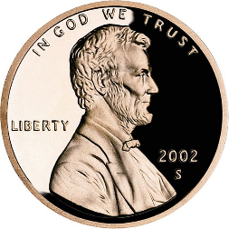
- The probability of an event happening in a random experiment is the ____________ (fraction) of the number of _________________ _________________ as the numerator over the _____________ number of outcomes as the denominator.

What is the probability of a penny landing heads up when it is tossed?
Successful Outcomes ________ So, there is a $\frac{1}{2}$, or ______ out of ______ chance
Total # of Outcomes of flipping a coin and getting a “head.”

Example Problem 1:
What is the probability that a green candy will be pulled out on the first try?

Blue candy?

Red candy?

Example Problem 2: A box contains 20 marbles – 12 red, 3 blue, and 7 green. Write each ratio in lowest terms.
blue marbles to green marbles green marbles to all the marbles

red marbles to blue marbles red marbles to all the marbles

Define Theoretical Probability | Give the formula for theoretical probability
the number of possible ways an event can happen compared to all possible outcomes. It is based on __________________________ ________________________.
Example Problem #3 What is the theoretical probability of getting a sum that is an odd number on one roll of two fair number cubes?

Practice Problems:
- Tierra rolls a fair dice. What is the theoretical probability that she will roll a number greater than 4?

- A bucket contains 15 blue pens, 35 black pens, and 40 red pens. You pick one pen at random. Find each theoretical probability:
  - P(black pen) b) P(blue pen or red pen)

- P(not a blue pen) d) P(black pen or not a red pen)

Define Experimental Probability | Give the formula for experimental probability
the ratio of actual outcomes to trials performed. Experimental probability is based on an _______________ _____________________________.

Example Problem #4 A softball player got a hit in 20 of her last 50 times at bat. What is the experimental probability that she will get a hit in her next at bat?

Practice Problems:
- A baseball player got a hit in 12 of his last 40 at bats. What is the probability that he will get a hit in his next at bat?

- A pitcher struck out 8 of the last 32 batters that he faced. What is the probability that he will strike out the next batter that he faces?

