**Unit 8 #2 Counting Principle of Multiplication**

Computer Science, Statistics and Probability all involve counting techniques which are a branch of mathematics called combinatorics (ways to combine things). We'll be introducing this topic in this section.

EXAMPLE 1: For dinner you have the following choices:

fd00403_bd08897_fd00471_bd08904_[](http://www.jledu.com.cn/kbsc/graph/enghish/lt2/unit5/salad.jpg)fd00452_ENTREES: soup & salad MAINS: chicken, prawns, hamburger DESSERTS: ice cream & π

How many different combinations of meals could you make? (We'll build a tree diagram to show all of the choices.)

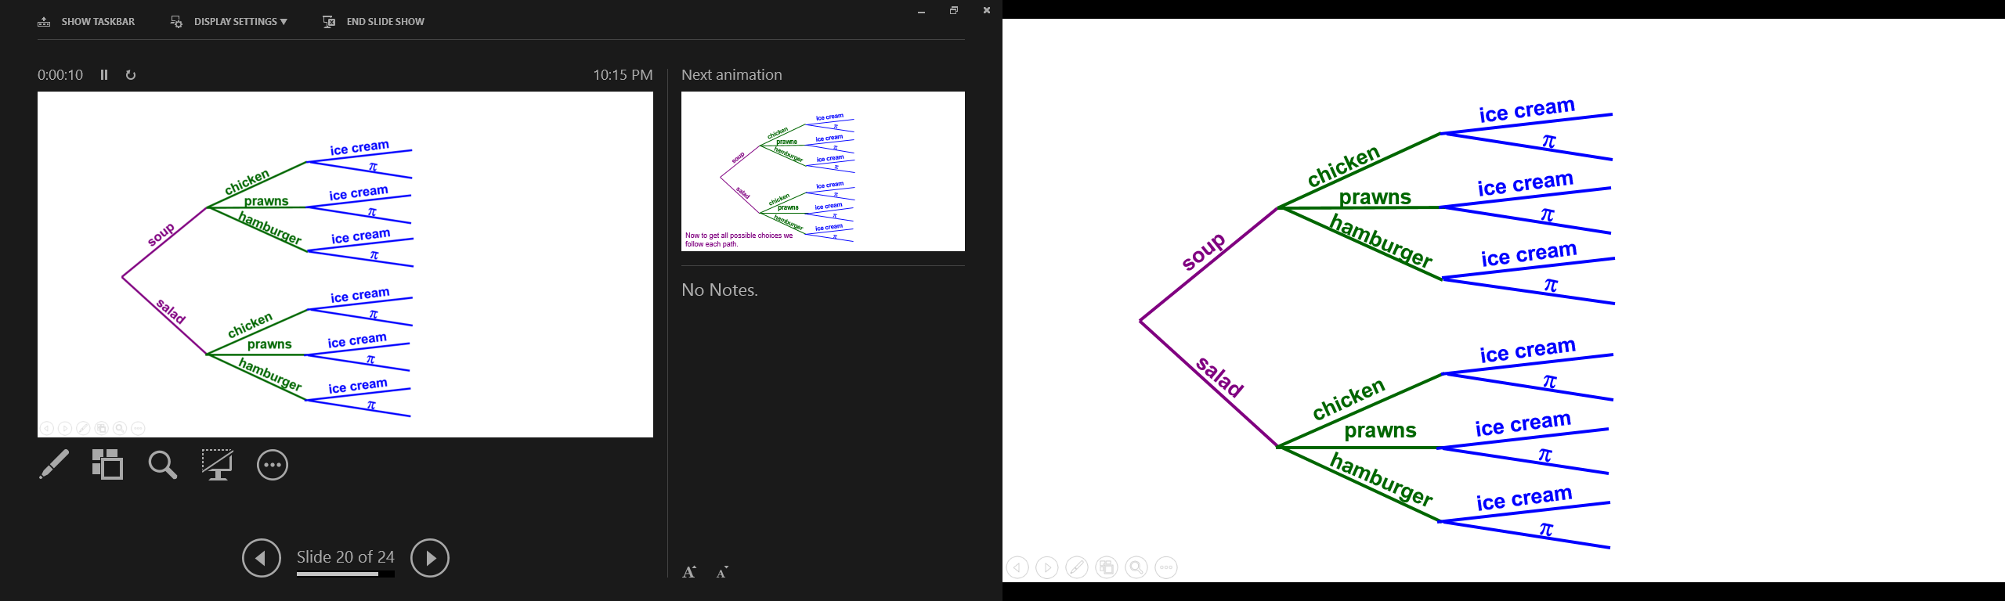

Multiplication Principle of Counting

If a task consists of a \_\_\_\_\_\_\_\_\_\_\_\_\_\_\_\_\_ of choices in which there are *p* selections for the first choice, *q* selections for the second choice, *r* selections for the third choice, and so on, then the task of making these selections can be done in different ways.

*p* × *q* × *r* × …

EXAMPLE 2: If we have 6 different shirts, 4 different pants, 5 different pairs of socks and 3 different pairs of shoes, how many different outfits could we wear?

PRACTICE PROBLEM: If you go into a sandwich shop and they have 4 different kinds of bread, 5 different meats, and 2 different kinds of cheeses how many combinations can you make?