Unit 4 #2 Translations
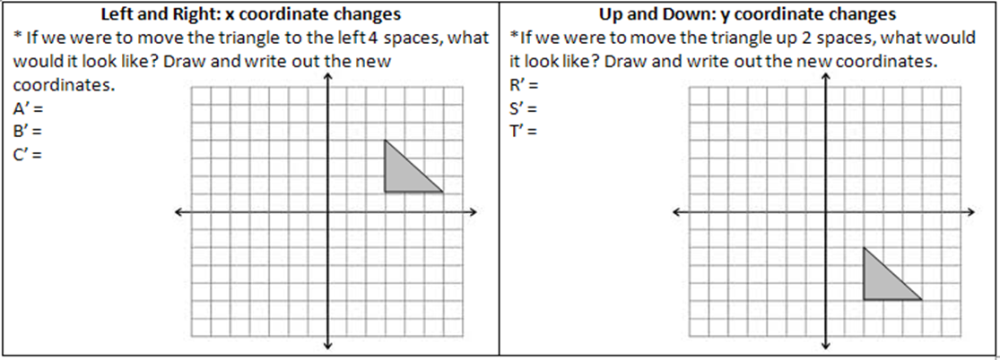
Example Problems: Graph the image of the figure using the transformation given.
Practice Problems:
Symbolic Notation: For example, if a rule tells me to translate a figure left 3 and up 5, the symbolic notation would be would be
(x,y) (_____________, _____________). This means we subtract 3 from x because we move left, and add 5 to y to move up.
YOU TRY: Translate each rule into symbolic notation:
- Move right 6 and down 1 b. Move left 4 c. Move up 3, left 2

MORE PRACTICE: Write a rule to describe each transformation.

Unit 4 #3 Dilations

Types of Dilations:
- Reduction: _______________________
- Enlargement: _____________________
- Congruence:______________________
Tips:
1. Dilation of a segment length: making a segment ____________________ or ________________________. NOT to be used with
figures on the coordinate plane!
*Formula: ____________________________
2. Dilations in the coordinate plane: _________________________ the scale factor by all _____________________________.
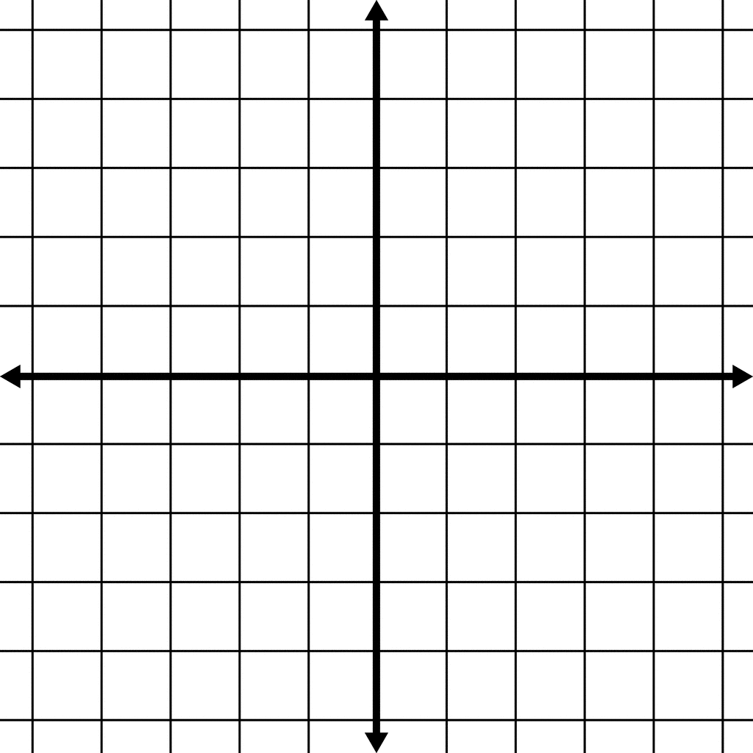
Example 1: Find the measure of S'T', given ST = 3 and r = 4. Example 3: Dilate LMN: L(-2,1) M(4,-1) N(4,3) by a scale factor of ½.

Example 2: Find the measure of ST, given S'T' = 8 and r = -2.

Unit 4 #3 Dilations

Types of Dilations:
- Reduction: _______________________
- Enlargement: _____________________
- Congruence:______________________
Tips:
1. Dilation of a segment length: making a segment ____________________ or ________________________. NOT to be used with
figures on the coordinate plane!
*Formula: ____________________________
2. Dilations in the coordinate plane: _________________________ the scale factor by all _____________________________.
Example 1: Find the measure of S'T', given ST = 3 and r = 4. Example 3: Dilate LMN: L(-2,1) M(4,-1) N(4,3) by a scale factor of ½.

Example 2: Find the measure of ST, given S'T' = 8 and r = -2.

