Unit 6 #2 Trigonometric Ratios – Sides
SINE (“sign”)  sin 18º =  sin 22º =  sin 65º =  sin 212º = | COSINE (“co-sign”)  cos 18º =  cos 22º =  cos 65º =  cos 212º = | TANGENT (“tan-gent”)  tan 18º =  tan 22º =  tan 65º =  tan 212º = | Ѳ (“theta”)  Represents an _________ angle  *If you see this symbol, make sure your calculator is in _________ mode!
Sin Ѳ = -------------- | Cos Ѳ = -------------- | Tan Ѳ = --------------
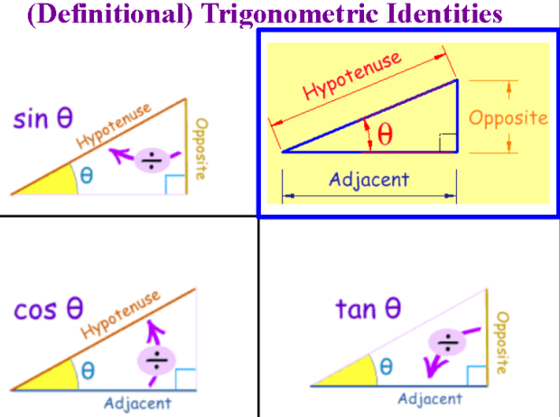
How will we ever remember this?? The Story of SOHCAHTOA and
This old hippie can help!
S ___________ S ___________
O ___________ O ___________
H ___________ H ___________
C ___________ C ___________
A ___________ A ___________
H ___________ H ___________
T ___________ T ___________
O ___________ O ___________
A ___________ A ___________

Finding Sin, Cos, & Tan
Example 1. Find the sin, cos, and tan of θ Example 2. Find the sine, cosine, and tangent of angle A.

Practice Problem 1. Find the values of the three trigonometric Practice Problem 2. Find the sine, cosine, and tangent of
functions of Ѳ. angle A.

Finding a side
1. A surveyor is standing 50 feet from the base of a 2. A person is 200 yards from a river. Rather than walk
large tree. The surveyor measures the angle of elevation directly to the river, the person walks along a straight
to the top of the tree as 71.5º. How tall is the tree? path to the river’s edge at a 60º angle. How far must
the person walk to reach the river’s edge?
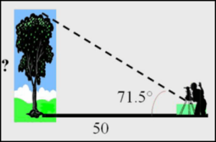

Whiteboard Practice: Find each unknown angle using a trigonometric ratio.

10. The angle of depression from the top of a tree
11. At 57" from the base of a building you need to look
is 16º. If the worm is 14 inches from the base up at 55° to see the top of a building. What is the height
of the tree, how tall is the tree?
of the building?

