Unit 7 #2 Volume & Surface Area

 | Volume | Surface Area | Picture
Rectangular Prism |  |  | 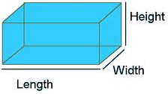
Square Pyramid |  |  | 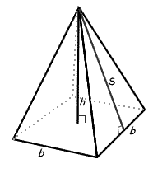
Cone |  |  | h  r
Cylinder
Sphere |  |  | r
Example 1: Find the volume of a rectangular prism with length 3 inches, width 8 inches, and height 2 inches.

Example 2: Find the surface area of a prism with a right triangular a base of length 21 inches, width of 20 inches and a height of 10 inches.

Example 3: The Great Pyramid of Giza has a height of 139 meters and a base side of 756 meters. Find the volume.

Example 4: The surface area of a square pyramid is 224 square inches. The sides of the base are 8 inches; find the slant height.

Example 5: Your ice cream cone is 7 inches tall. The diameter of the opening of the cone is 2 inches. How much ice cream can the cone hold if you don’t fill it past the brim?

Example 6: The surface area of a cone is 300π. If the radius is 12 inches, find the slant height.

Example 7: The giant can of soup Ms. Santos brought for lunch has a volume of 504cm³ and a diameter of 12 cm. How tall is her can?

Example 8: A can of soup has a diameter of 4 inches and a height of 6 inches. Find the area of the label.

Example 9: Calculate the volume of helium needed to inflate a spherical latex balloon with a diameter of 18 inches.

Example 10: The circumference of a baseball is 84Π centimeters. Find the surface area of the ball.

