TRIANGLE SUM THEOREM
Definition | Numbers | Algebra
The interior angle measures of a triangle add up to ______ | ____ + ____ + ____ = ______ | ____ + ____ + ____ = ______
Example Problems: Find the measure of the missing angle.

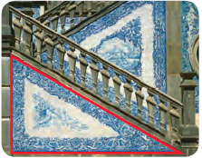
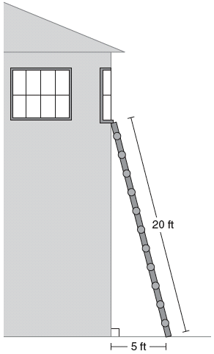
Application Problems:
1. The ladder is leaning on the 2. WINTER IS COMING! The tile on your
ground at a 75º angle. At what
porch staircase forms a right triangle.
angle is the top of the ladder
The measure of one frosted acute
touching the building? angle in the triangle is twice the
measure of the other angle. Find the measure of each
acute angle.

Equilateral Triangles Isosceles Triangle
Find the missing angle. Find the missing angle.

