Unit 5: #4 Exterior Angle Theorem
EXTERIOR ANGLE THEOREM (REMOTE INTERIOR ANGLE THEOREM)
Definition | Numbers | Algebra
The measure of an exterior angle of a triangle is the sum of the remote interior angles | ____ + ____ = ____ | 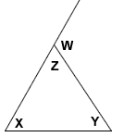  ____ + ____ = ____
Example Problems:
- Find the missing angle. 2. Solve for x. 3. Find the m∠H.
WHITEBOARD PRACTICE!
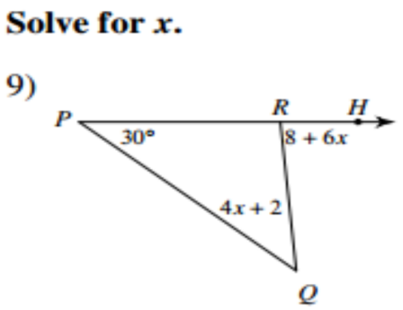
Find the measure of the angle indicated.

