**Back to Warm Up ☺**

Your favorite dog groomer charges according to your dog’s weight.  If your dog is 15 pounds and under, the groomer charges $35.  If your dog is between 15 and 40 pounds, she charges $40.  If your dog is over 40 pounds, she charges $40, plus an additional $2 for each pound.

1. Graph the function.

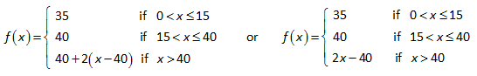

Go back to your original graph and compare your answer to the answer   
we just did together.

1. Were there any similarities in your first graph and the piecewise   
   function graph? What were they? _____________________________________________________________  
   __________________________________________________________________________________________________________________________
2. Were there any differences in your first graph and the piecewise function graph? What were they?

**_______________________________________________________________________________________________________________________________________________________________________________________**

**Graphing Piecewise Functions**

1. f(x) = x2 + 1, x ≥ -1 ___________________ -3x – 1, x < -1 ___________________

**STEPS:**   
1. Determine the _______________ of the graphs.  
2. Draw the _____________________ of each graph (Draw the fences.)   
3. Draw each _____________. (Draw each neighbor on his side of the fence.)

4. Draw _____________ or _____________ circles. (Who owns the fence?)



Continuous or Discontinuous?

1. f(x) = 3x + 2, x < -2 ___________________

-x, -2 < x < 1 ___________________

x2 – 2, x >1 ___________________   
1. Determine the shapes of the graphs.  
2. Draw the boundaries of each graph (Draw the fences.)   
3. Draw each graph. (Draw each neighbor on his side of the fence.)

4. Draw open or closed circles. (Who owns the fence?)



Continuous or Discontinuous?

**Step Functions**

A piecewise function that is constant for each interval of its domain, such as the ticket price function, is called a **_________________________**. Basically the graph looks like a ___________________ of __________________. You can describe piecewise functions with a function rule. See the example below:

f(x) = 5, 0 < x < 13

9, if 13 < x < 55

6.5, if x > 55

*Read this as:*

“f of x is ___________ if x is _____________ than 0 and less than _____________, _________ if x is greater than or ____________to 13 and less than ______________, and _______________if x is greater than or equal to ______________.”

**Graphing Step Functions**

Graph the step function below:

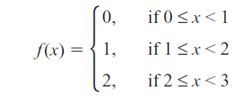

Closed circle: _______________________

-6

if x < -2

Open circle: ________________________

7

-1

If -2 ≤ x < 4

if x ≥ 4



**PRACTICE PROBLEMS** Carefully graph each of the following. Identify whether each function is continuous or discontinues. Then evaluate the function at each specified domain value (x). You can also make a table of x- & y- values to help you.

1. 



Continuous or discontinuous?

f(3) =

f(-4) =

f(-2) =

1. *f(x)* = 



Continuous or discontinuous?

f(-2) =

f(0) =

f(5) =