Unit 4 #4 Reflections
Rules for reflections: Use ΔMNP: M(6,1), N(3, -7), P(8, -5) as an example
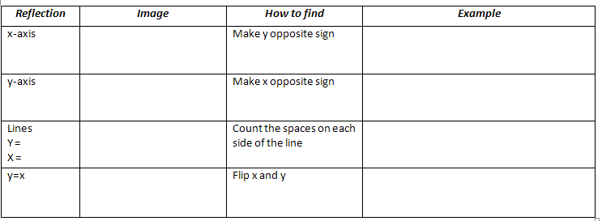
Example 1: Give the new coordinates for the reflection of triangle RST: R(-2, 0) S(5, 4) T(1, -1)
a. over y = x b. over origin c. over y axis
R' = R' = R' =
S' = S' = S' =
T' = T' = T' =

Unit 4 #5 Rotations
**All rotations are done unless otherwise stated.
**Three angles used: __
ROTATION RULES
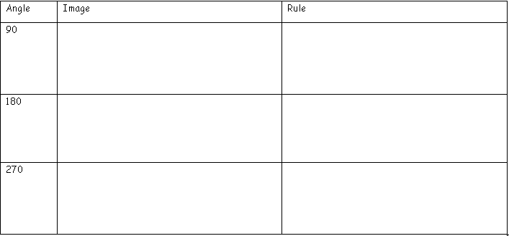
Tips:
For Clockwise Rotations:
: use 270 rule : use 180 rule : use 90 rule

Example 2: Reflect ABC over the x axis. Example 3: Reflect ABC over the line y = -2.
Use the x-axis as the line of symmetry. A(-2, -3), B(5, -3), C(1, -2)
A(-2, -3), B(5, -3), C(1, -2)
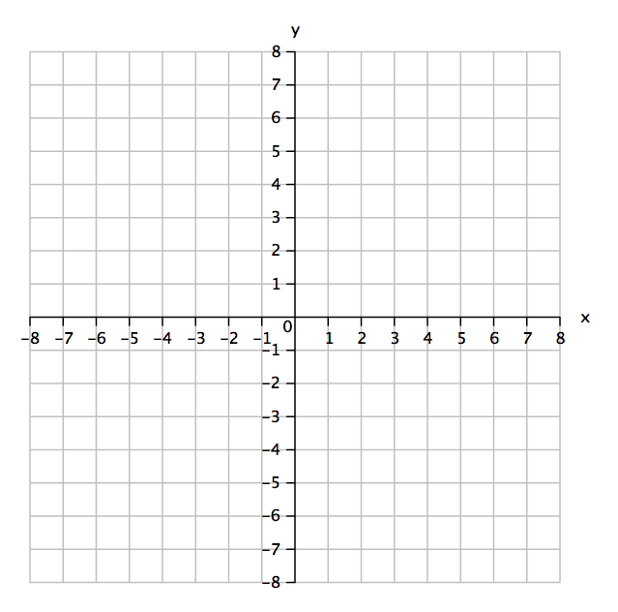

Examples:
1. Rotate 270: ΔABC: A(6,2) B(-3,4) C(8,5) 2. Rotate 90: ΔXYZ: X(3,-4) Y(7,2) Z(-6,5) 3. Rotate 180: ABCD: A(5,9) B(8,9) C(8,4)
D(5,4)

