Unit 5 #5 Isosceles Triangle Theorem
Isosceles Triangle: A triangle with at least __________ sides and angles congruent.
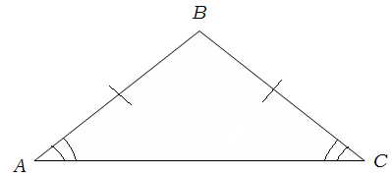
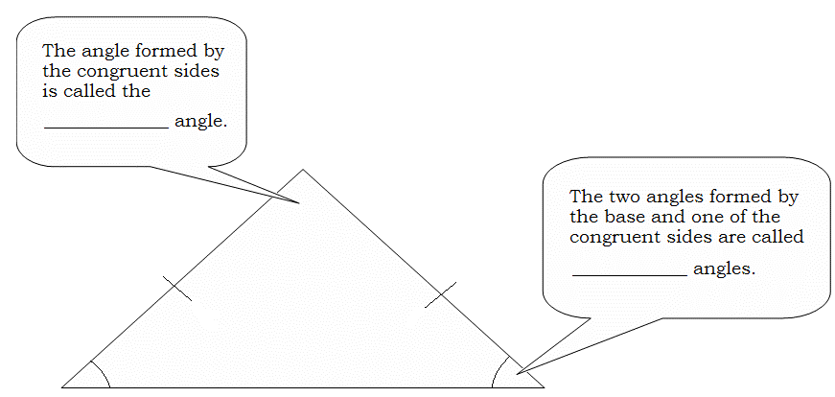
Isosceles Triangle Theorem: If two sides of a triangle are ____________________, then the angles opposite those sides are ____________________.
Example: _________________________________

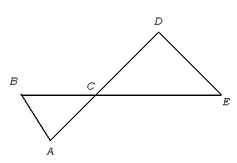
Example 1: If $\overline{DE}≅\overline{CD}$, $\overline{BC}≅\overline{AC}$,and m∠CDE = 120º, what is the measure of ∠BAC?

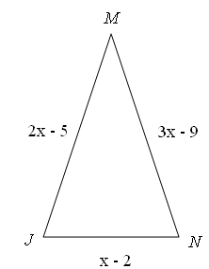
Example 2: Find x, $\overline{JM}$, $\overline{MN}$, and JN if ∆JMN is an isosceles triangle with ∠J ≅ ∠N.

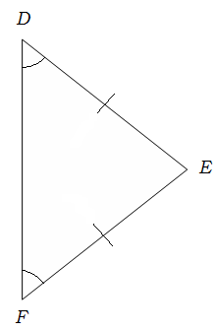
Example:
Converse to Isosceles Triangle Theorem: If two angles of a _______________ are congruent, then the sides opposite those angles are ___________________.
________________________________

Example 3:
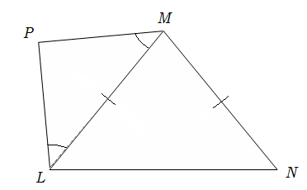
a.) Name all of the congruent angles. b.) Name all of the congruent segments.
_____________________ _____________________
_____________________ _____________________

Example 4: Find the measures of angles 1, 2, 3, and 4.

