Unit 6 #5 Law of Cosines

*Usually used when you have ___________ or ___________.
USE LAW OF COSINES WHEN…
- You know the length of all three __________ of a triangle and are trying to find an ______________.
- You know two ___________ and an included ____________ and are trying to find the side __________________ the angle.
a² = ______________________________

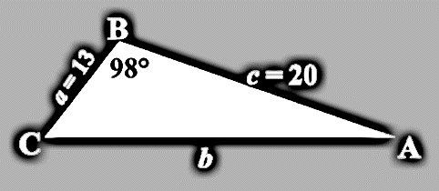
Example 1: Given SAS: Find the length of $\overline{AC}$, given that angle B = 98º, side a= 13 and side c= 20.

Practice Problems: Find the value of x.
1. 2.

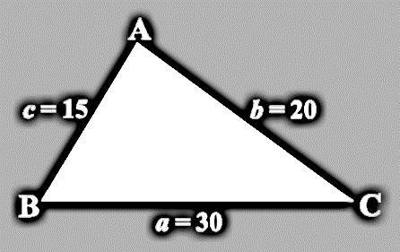
Example 2: Given SSS: Find m∠B, given that side a = 30, side b = 20, and side c = 15.

Practice Problems: Find the values of x and y. Hint: You will have to use the Law of Cosines twice!
3. 4.

Unit 6 #6 Law of Sines

*Usually used when you have ___________ or ____________
USE LAW OF SINES WHEN…
- You know two __________ and an ____________ side and are trying to find the angle ________________ the side.
- You know two ____________ and a non-included _________ and are trying to find a missing _____________.

$\frac{\sin{( )}}{}$ = $\frac{\sin{( )}}{}$ = $\frac{\sin{( )}}{}$

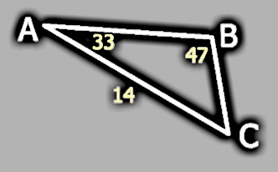
Example 1: Find the missing angle. In the triangle below, m∠A = 33º, m∠B = 47º and b = 14. Find the length of $\overline{BC}$.

Practice Problem: Find all missing angles and sides in the triangle below: m∠A = 28º, a = 12, and b = 24.
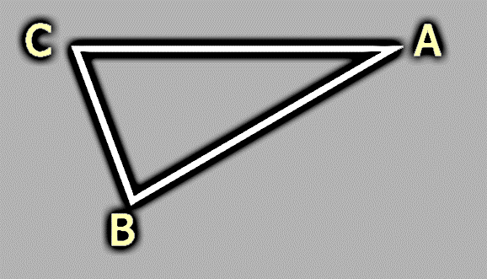

Example 2: A civil engineer wants to determine the distances from points A and B to an inaccessible point C. From direct measurement, the engineer knows that AB = 25m, m∠A = 110º, and m∠B = 20º. Find AC and BC.

