Unit 7 #5 Partitioning Directed Line Segments

What is a directed line segment?
- A directed line segment is a segment between two points A and B with a __________________ direction, from A to B or from B to A. To ________________________ a directed line segment is to divide it into two segments with a given __________________.

- How to find the Coordinates of a Point in a Directed Line Segment
- Identify the ___________ from start point to end point.
- Find the change in ______ and the change in ______.
- __________________ the change in x’s and the change in y’s by the _________ from start point to end point.
- _________ or __________________ these values from your ___________ point.

Example 1: Finding the Coordinates of a Point in a Directed Line Segment
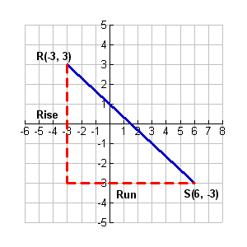
- Find the point Q along the directed line segment from point R(–3, 3) to point S(6, –3) that divides the segment into the ratio 2 to 1.

Step 1
 | X’s | Y’s
Step 2
Step 3
Step 4

Example 2: Find the coordinates of the point P that lies along the directed segment from A(1, 1) to B(7, 3) and partitions the segment in the ratio of 1 to 4.
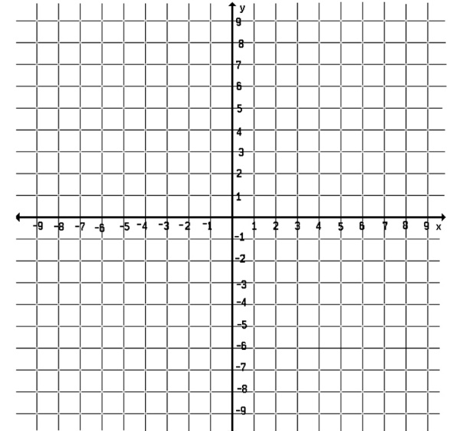

Practice Problem: Find the point Q along the directed line segment from point R(–2, 4) to point S(18, –6) that divides the segment in the ratio 3 to 7.
