Unit 2 #5 RADICAL EXPRESSIONS & EQUATIONS
RADICAL EXPRESSIONS
PERFECT SQUARES Example $\sqrt{18}$
STEPS TO SIMPLIFYING RADICAL EXPRESSIONS:
1. Factor the _______________.
2. Make sure one of the factors is a _____________
square.
3. Take the ____________ ________ of the
_____________ perfect square factor.
4. ______________ what’s left in the radicand.
$$\sqrt{a^{2}}$$
$$\sqrt{4}$$
$$\sqrt{9}$$
$$\sqrt{16}$$
$$\sqrt{25}$$
$$\sqrt{36}$$
$$\sqrt{49}$$
$$\sqrt{64}$$
$$\sqrt{81}$$

Practice Problems
1. $\sqrt{24}$ 2. $\sqrt{108}$ 3. $\sqrt{27}$ 4. $\sqrt{72}$ 5. $\sqrt{96}$

RADICAL EQUATIONS
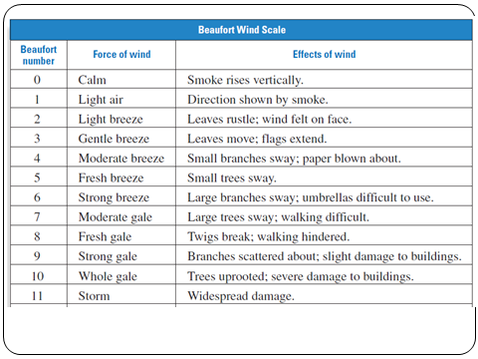
Beaufort Wind Scale! The Beaufort Wind Scale was devised to measure wind speed. The Beaufort number, B, which range from 0-12, can be modeled by B = 1.69$\sqrt{s+4.45}$ – 3.49 where s is the speed (in miles per hour) of the wind.
If the sailors have the best and safest wing when the Beaufort number is 6, how fast is the wind moving?

SO WHO WON AMERICA’S CUP LAST YEAR?
TO SOLVE A RADICAL EQUATION CONTAINING ONE SQUARE ROOT:
- ___________ the radical on one side of the equation.
- ___________ both sides of the equation.
- Solve for the ______________.
- ___________ the solutions.

PRINCIPLE FOR SOLVING RADICAL EQUATIONS:
If ______ and ______ are real numbers, n is a positive integer, and a = b, then:

Example Problems 1. $\sqrt{x+3}$ – 5 = 0 2. 10 = $\sqrt[3]{6x-2}$

3. A ten-foot board leans against an 8-foot wall so that the top end of the board is at the top of the wall. How far must the bottom of the board be from the wall? Let x be the distance from the bottom of the board to the wall. Use the Pythagorean Theorem.

