Unit 5 #6 CPCTC
DEFINITION OF CONGRUENT TRIANGLES (CPCTC):
*Two triangles are congruent if and only if their corresponding parts are ___________________________.
*CPCTC: ___________________ parts of ___________________ triangles are ___________________.

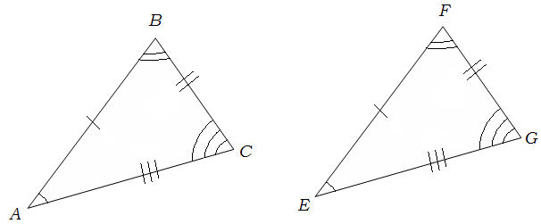
Example 1:
- Name all corresponding angles.
____________ ____________ ____________
- Name all corresponding sides.
____________ ____________ ____________
- Write a congruence statement.
__________________________
Example 2: In the diagram, DEFG ≅ KLMN.
- Find the value of x.

- Find the value of y.

PROPERTIES OF TRIANGLE CONGRUENCE
Reflexive | Symmetric | Transitive
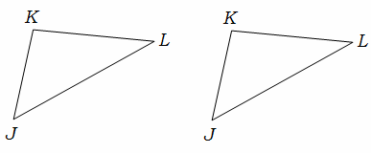 | 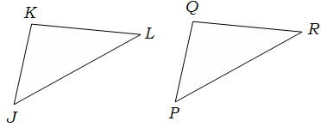 | 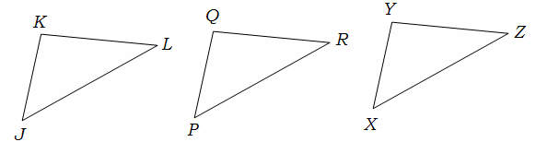
Definition: any quantity is congruent to itself  Example: | Definition: If a = b, then b = a.  Example: | Definition: If a = b and b = c, then a = c.  Example:

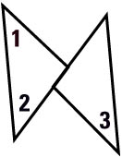
Example 3: This two=column proof uses the Transitive Property.
GIVEN m∠3 = 40º, ∠1 ≅ ∠2, ∠2 ≅ ∠3
PROVE m∠1 = 40º

Statements | Reasons
1.

2.

3.

4.

