DIRECTIONS: The discriminant is found by using the formula b²-4ac. Find the discriminant for the following equations then sketch a rough graph without using a calculator. Answer al the questions about the discriminant.
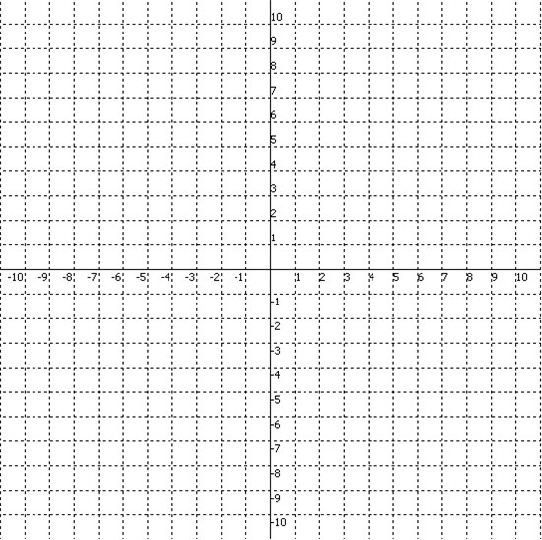
- 2x² – 7x + 3
Find the discriminant:

Is the discriminant positive, zero, or negative?
How many roots or zeroes does this quadratic equation have?
- 2x² – 9
Find the discriminant:

Is the discriminant positive, zero, or negative?
How many roots or zeroes does this quadratic equation have?

- 2x² – x + 3
Find the discriminant:

Is the discriminant positive, zero, or negative?
How many roots or zeroes does this quadratic equation have?

- x² + 4x + 5
Find the discriminant:

Is the discriminant positive, zero, or negative?
How many roots or zeroes does this quadratic equation have?

- x² + 4x + 4
Find the discriminant:

Is the discriminant positive, zero, or negative?
How many roots or zeroes does this quadratic equation have?

- x² + 8x + 16
Find the discriminant:

Is the discriminant positive, zero, or negative?
How many roots or zeroes does this quadratic equation have?

- Discriminants tell us how many roots a quadratic equation has. How many roots do positive discriminants have? Negative discriminants? How many roots do discriminants with a value of zero have?

