#6 THE DISCRIMINANT
Example Problems 1.) x² – 5x – 14 = 0 2.) 2x² + x – 5 = 0
THE DISCRIMINANT!

3.) x² – 10x + 25 = 0 4.) 4x² – 9x + 7 = 0

Discriminant Chart
Value of Discriminant | Type and Number of Roots | Sample Graph of Related Function
D>0 (+) and D is a  ______________ _____________ |  | 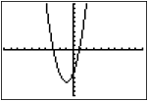
D>0 (+) and D NOT a
______________ _____________

D = 0 |  | 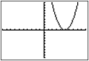
D<0 ( ─ ) |  | 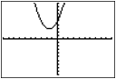

#6 THE DISCRIMINANT
Example Problems 1.) x² – 5x – 14 = 0 2.) 2x² + x – 5 = 0
THE DISCRIMINANT!

3.) x² – 10x + 25 = 0 4.) 4x² – 9x + 7 = 0

Discriminant Chart
Value of Discriminant | Type and Number of Roots | Sample Graph of Related Function
D>0 (+) and D is a
______________ _____________

D>0 (+) and D NOT a
______________ _____________

D = 0
D<0 ( ─ )

