Unit 5 #7 Triangle Congruence

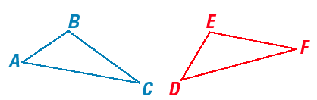
SSS and SAS Congruence Postulates

If Sides are congruent and Angles are congruent then Triangles are congruent
1. _______________ 4. _______________
2. _______________ 5. _______________ _______________
3. _______________ 6. _______________

SIDE-SIDE-SIDE (SSS) CONGRUENCE POSTULATE | SIDE-ANGLE-SIDE (SAS) CONGRUENCE POSTULATE
If ____________ sides of one triangle are congruent to three _____________ of a second triangle, then the two triangles are _________________.  If _______ ≅ _______  _______ ≅ _______ then _______ ≅ _______  _______ ≅ _______  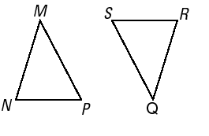 | If two sides and the ___________________________ of one triangle are congruent to __________________ and the included angle of a second triangle, then the two triangles are ___________________.  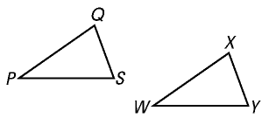  If _______ ≅ _______  _______ ≅ _______ then _______ ≅ _______  _______ ≅ _______

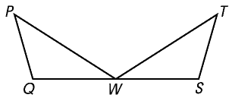
Example 1: Using the SSS Congruence Postulate
Prove that ΔPQW ≅ ΔTSW

STATEMENT | REASON
1) | 1)
2) | 2)

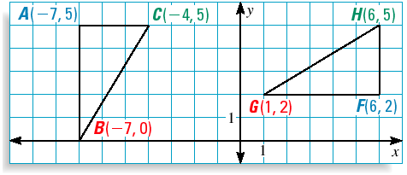
Example 2: Congruent Triangles in a Coordinate Plane
Use the SSS Congruence Postulate to show that ΔABC ≅ ΔFGH.

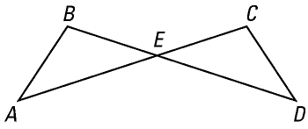
Example 3: Using the SAS Congruence Postulate
Prove that ΔAEB ≅ ΔDEC

STATEMENT | REASON
1) | 1)
2) | 2)
3) | 3)

Example 4: Applying Triangle Congruence Using Proofs
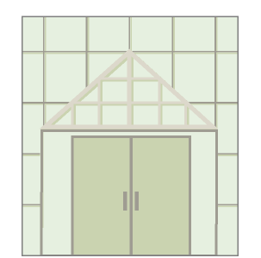
ARCHITECTURE: You are designing the window shown in the drawing. You want to make Δ DRA congruent to Δ DRG. You design the window so that $\overline{DR}$ ⊥ $\overline{AG}$ and $\overline{RA}$ ≅ $\overline{RG}$.
D
G
A
R
Can you conclude that ΔDRA ≅ ΔDRG?

Given $\overline{DR}$ ⊥ $\overline{AG}$
$\overline{RA}$ ≅ $\overline{RG}$
Prove ΔDRA ≅ ΔDRG
STATEMENT | REASON
1) | 1)
2) | 2)
3) | 3)
4) | 4)
5) | 5)
6) | 6)

