**UNIT 5 #7 TRIANGLE CONGRUENCE (CONT.)**

|  |  |
| --- | --- |
| **HYPOTENUSE-LEG (HL) CONGRUENCE POSTULATE** | **ANGLE-SIDE-ANGLE (ASA) CONGRUENCE POSTULATE** |
| If the _________________ and a leg of a right Δ are ≅ to the hypotenuse and a ________ of a ____________ second Δ, then the 2 Δs are __________________.  If _______ ≅ _______  _______ ≅ _______ then _______ ≅ _______ | If two angles and the **_______________________** of one triangle are congruent to **____________________** and the included side of a second triangle, then the triangles are **_________________**.    If _______ ≅ _______  _______ ≅ _______ then _______ ≅ _______  image2.gif                                                     0000D0C8Christine's Mac                B472C195: _______ ≅ _______ |

|  |
| --- |
| **ANGLE-ANGLE-SIDE (AAS) CONGRUENCE POSTULATE** |
| If two angles and a _______________________ side of one triangle are congruent to _____________________ and the corresponding non-included side of a second triangle, then the triangles are _________________.  If _______ ≅ _______  _______ ≅ _______ then _______ ≅ _______  _______ ≅ _______  image2.gif                                                     0000D0C8Christine's Mac                B472C195: |

**Example 1:** Is it possible to prove these triangles are congruent? If so, state the postulate or theorem you would use. Explain your reasoning.

**GIVEN 🡪**

**PROVE 🡪**

|  |  |
| --- | --- |
| *STATEMENT* | *REASON* |
|  |  |
|  |  |
|  |  |
|  |  |
|  |  |
|  |  |
|  |  |

**Example 2:** Is it possible to prove these triangles are congruent? If so, state the postulate or theorem you would use. Explain your reasoning.

Yes or No? _______________

Why? __________________________________

**Example 3: YOU TRY!**

Given: AD║EC, BD ≅ BC

Prove: ∆ABD ≅ ∆EBC

|  |  |
| --- | --- |
| *STATEMENT* | *REASON* |
|  |  |
|  |  |
|  |  |
|  |  |
|  |  |
|  |  |
|  |  |
|  |  |

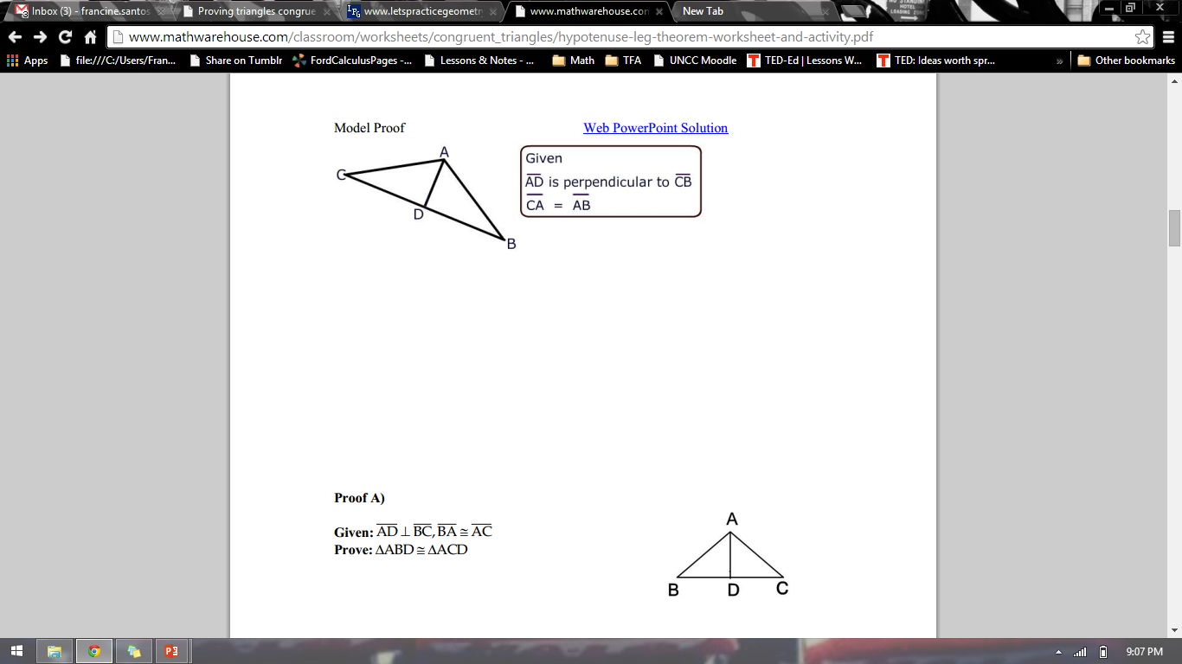

**Example 4:**

GIVEN 🡪 ⊥

≅

PROVE 🡪 ∆ABD ≅ ∆ACD

|  |  |
| --- | --- |
| *STATEMENT* | *REASON* |
|  |  |
|  |  |
|  |  |
|  |  |
|  |  |
|  |  |
|  |  |

**Example 5:** ΔJKL ≅ ΔMNO, m∠K = (3x + 7)o, m∠N = (2x + 24)o, m∠L = (5x – 42)o, and m∠O = (4x – 25)o. Find the measure of ∠M.

