**#8 GRAPHING QUADRATICS**

KEY POINTS:

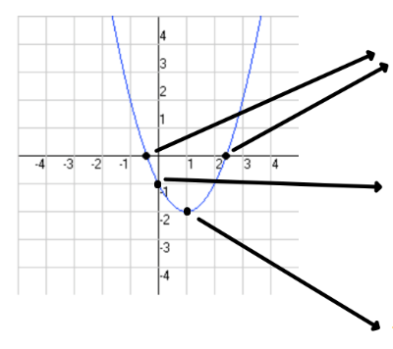

**GRAPHING BY HAND: y = x2 – 4x + 4**

1. Find the vertex How do I do that?

_____________________

1. 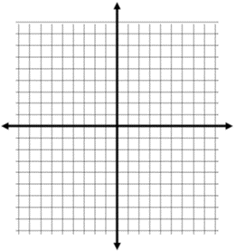Make a table of values 3. Plot your points.

|  |  |
| --- | --- |
| X | Y |
|  |  |
|  |  |
|  |  |
|  |  |
|  |  |

Solutions are: ___________________

Vertex here!

**#8 GRAPHING QUADRATICS**

KEY POINTS:



**GRAPHING BY HAND: y = x2 – 4x + 4**

1. Find the vertex How do I do that?

_____________________

1. Make a table of values 3. Plot your points.

|  |  |
| --- | --- |
| X | Y |
|  |  |
|  |  |
|  |  |
|  |  |
|  |  |

Solutions are: ___________________

Vertex here!

**GRAPHING USING A CALCULATOR: y = x2 + 2x – 3**

* Y = 🡪 enter equation
* GRAPH
* VERTEX
  + 2nd TRACE (CALC)
    - 3: minimum or 4: maximum
      * Left Bound? 🡪 move cursor (blinking dot) to left side of vertex & hit enter
      * Right Bound? 🡪 move cursor to right side of vertex & hit enter
      * Guess? 🡪 hit enter
* X-INTERCEPTS
  + 2nd TRACE (CALC)
    - 2: zero
      * Left Bound? 🡪 On left leg, move cursor to left side of x-axis & hit enter
      * Right Bound? 🡪 On left leg, move cursor to right side of x-axis & hit enter
      * Guess? 🡪 hit enter
  + Repeat for right leg

Solutions are: ____________________

**GRAPHING USING A CALCULATOR: y = x2 + 2x – 3**

* Y = 🡪 enter equation
* GRAPH
* VERTEX
  + 2nd TRACE (CALC)
    - 3: minimum or 4: maximum
      * Left Bound? 🡪 move cursor (blinking dot) to left side of vertex & hit enter
      * Right Bound? 🡪 move cursor to right side of vertex & hit enter
      * Guess? 🡪 hit enter
* X-INTERCEPTS
  + 2nd TRACE (CALC)
    - 2: zero
      * Left Bound? 🡪 On left leg, move cursor to left side of x-axis & hit enter
      * Right Bound? 🡪 On left leg, move cursor to right side of x-axis & hit enter
      * Guess? 🡪 hit enter
  + Repeat for right leg

Solutions are: ____________________