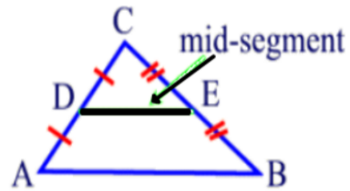
Unit 5 #8 Midsegment Theorem
PROPERTIES
- The mid-segment of a triangle joins the _________________ of two sides of a triangle such that it is __________________ to the third side of the triangle.
- The ____________________ of a triangle joins the midpoints of two sides of a triangle such that its ________________ is ____________ the length of the _______________ side of the triangle.
SO WHAT DOES THAT MEAN??
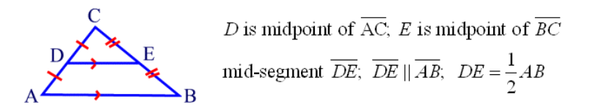
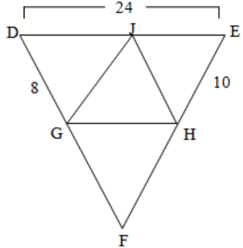
Example 1: Find the length of the midsegment GH. Example 2: Given DE is the midsegments of AB, DF
is the midsegments of CB, & EF is the midsegment
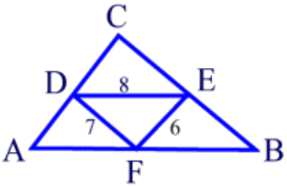
of AC, Find the perimeter of ΔABC.

Examples: Find the value of the variable.
3. 4.
Example 5: Find the length of SQ. Example 6: Find the length of the midsegments.

_______ + _______ = _______
Pythagorean Theorem:

Problem-Based Task: Life-Size Support
Alex is assembling a life-size cardboard cutout of his favorite musician. The package contains three pieces of cardboard: the cutout, which measures 66 inches; the horizontal, which measures 15.5 inches; and the angled support, which attaches to the back of the cutout at a point that is $\frac{2}{3}$ the length of the cutout from the floor. The horizontal support acts as the midsegments connecting the cutout and the angled support. What is the length of the angled support rounded to the nearest inch?
- If the cutout measures 66 inches, what is $\frac{2}{3}$ the length of the cutout?

- The horizontal support acts as the midsegment connecting the cutout to the angled support. How does the length of the midsegment compare to the side it is parallel to?

- If the horizontal support is 15.5 inches, what is the distance from the bottom of the angled support to the base of the cutout?

- How can you determine the length of the angled support?

- What is the length of the angled support rounded to the nearest inch?

