Can You Be the Next Picasso?
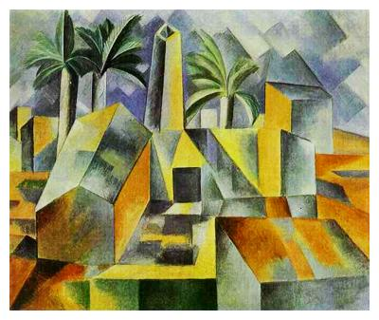
Pablo Picasso (1881 – 1973) was a Spanish artist who used many technical shapes and designs in many of his paintings. One style of art he created was called “cubism,” where he created art out of geometric shapes and their transformations. Now, you will get the chance to be Picasso!

For this assignment, you will create a shape with four points on the coordinate plane. It can be a common shape, like a rectangle, or any other quadrilateral you choose. Then, you will transform the shape at least five different ways based on the directions below to create your masterpiece!
Directions:
1. Draw and label your original figure on the graph paper provided. The figure must be a quadrilateral (with four points), and the points must be labeled ABCD.
2. Transform the shape 5 different ways around the plane using the rules we discussed in class. For these transformations, you must include at least one reflection, one rotation, one dilation, one translation, and one other of your choice. On separate paper, write the transformations you chose and the points that resulted. For example, your separate sheet should look like:
Original figure: A - B - C - D –
Rotation of 90⁰ Clockwise: A’ - B’ - C’ - D’ –
Dilation of scale factor 3: A’’ - B’’ - C’’ - D’’ –
Reflection over line y = x: A’’’ - B’’’ - C’’’ - D’’’ –
Translation (x – 2, y + 4): A’^{v} - B’^{v} - C’^{v} - D’^{v} –
Dilation of scale factor $\frac{1}{4}$: A^{v} - B^{v} - C^{v} - D^{v} –
Don’t use these – this is an example!
Rubric:
10 points – Completion on time and at standard (all points completed)
20 points – original figure
50 points – 5 accurate transformations (with points and figures)
20 points – Creativity (make it look nice, colorful, with the points exact on the plane)

