#1 ADDING & SUBTRACTING POLYNOMIALS Simplify the following completely:
1.) (6f² – 7f – 3) – (2f – 1 + 5f²) + (-3 + f + 2f²) 2.) 2(-b³ + 8c² + 5) – (3(7c² – 2 + b³)

3.) (8x³y – 7x² – 6xy² + 2(x³y – 3x² – 6xy²) 4.) (8x² – 4x – 3) – (-2x – 2x² + 5)

5.) (5x³ – 2x²y + 10xy³) – (6x³ – 5x²y + xy³) – (9x³ + 9x²y – xy³) 6.) 3(4x – 2xy) + 2(-3xy + 4)

#2 MULTIPLYING POLYNOMIALS
1.) Find the area of a rectangle with a length of 2.) Find the area of a square with a side length of (6x + 7).
2x + 1 and a width of x – 3.

3.) Find the area of a triangle with the following dimensions: 4.) Katherine and Danielle want to go on a picnic and need
6x³y⁴
to make sure that their blanket covers enough room in
the park. Their picnic blanket has a length of 2x – 4 and
a width of 4x + 8. Help them by calculating the area of
their blanket. (Draw a diagram to help you.)
3xy

#3 FACTORING QUADRATICS Pick 8 problems to solve. You must pick one of each factoring category (b & c positive, b negative & c positive, b positive & c negative, b & c negative, difference of squares, pull out GCF first) You may choose any 2 for the remaining problems. *All problems are factorable!
1.) x² + 6x + 8 2.) 5x² – 31x + 30 3.) 3x² – 7x - 20

4.) x² + 5x – 14 5.) x² – 13x + 42 6.) 7x² + 78x +80

7.) 2x² + 5x - 3 8.) x² – 36 9.) 6x² - x – 35

10.) 16x² – 25 11.) 12x² + 24x – 288 12.) 2x³ - 23x² + 45x

Extra Practice: Factor the following completely.
1.) x² + 5x + 6 2.) 5x² + 16x + 3 3.) 2x² + 15x + 7 4.) b² + 10b + 24

5.) x² – 10x + 9 6.) 5x² – 11x + 2 7.) x² – 14x + 24 8.) 2x² - 7x – 15

#4 SOLVING QUADRATICS BY FACTORING Factor completely. Then find all solutions.
1.) 0 = 16x² – 169 2.) 5x² + 15x – 50 = 0 3.) x² + 8x = 9 4.) x² – 10x = -16

5.) x² – 11x + 19 = -5 6.) 4v² – 4v – 8 = 0 7.) x² – 14x = - 40 8.) 0 = x² – 2x – 8

#5 DISCRIMINANT & QUADRATIC FORMULA Directions: For each of the following quadratic equations, Find the value of the discriminant, and describe the number and type of roots.
1. x² + 14x + 49 = 0 2. x² + 5x – 2 = 0 3. 3x² + 8x + 11 = 0 4. x² + 5x – 24 = 0

#6 GRAPHING QUADRATIC EQUATIONS Directions: Choose any 3 of the following quadratic equations and SOLVE by graphing. You may graph by finding the x- & y-intercepts and vertex OR by finding the vertex and making a table. You choose! Be sure to label the x-intercept(s), y-intercept, vertex, and axis of symmetry.
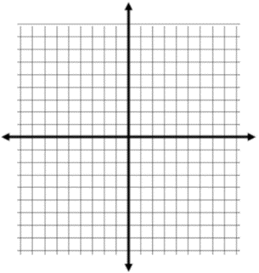
1. y = x² + 6x + 8 2. y = 3x² – 6x + 1 3. y = x² + 2x – 3 4. y = -x² – x – 1 5. y = 2x² – 10x + 8

#7 QUADRATIC WORD PROBLEMS
1.) The height, h(t), in feet of an object thrown into the air with an initial upward velocity of 63 feet per second is given by the formula h(t) = -16t² + 63t, where t is the time in seconds.

- What is the height of the object after 3 seconds?

b.) What was the maximum height
of the ball?

c.) How long does it take the ball to reach its maximum height?

2.) The function y = -2x² + 32x + 150 models the monthly flour expense last year at Antonio’s bakery, where x = 1 represents January.
a.) During the month of May, what is b.) What was the maximum flour c.) What month does the
the expense of flour? expense? maximum flour expense occur?
3.) A rocket is launched straight up into the air from a 25-foot high platform with a velocity of 198 feet per second. The height of the rocket in feet, h, is a function of the time after the rocket has been launched in seconds, t:
h = -16t² + 198t + 25.
a.) What was the height of the rocket 6 seconds after b.) How long did it take for the rocket to hit the ground?
it has been launched?

4.) Nick’s height in meters above the water t seconds after diving from a diving board into a pool can be modeled by
f(t) = -4.9t² + 4.9t + 5. What is Nick’s maximum height above the water?

#8 LINEAR-QUADRATIC SYSTEMS Directions: Solve each system. Don’t forget to solve for both pairs of x’s and y’s. Write your final answers as ordered pairs.
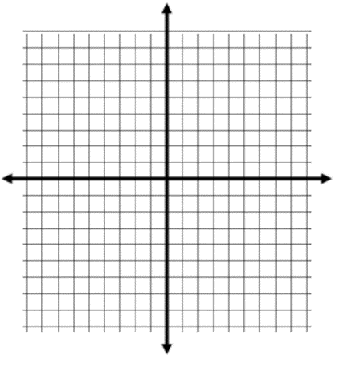
- y = x² – 2x – 6.
y = 4x + 10

- y = 3x – 20
y = -x² + 34

- y = x² + 7x + 100
y + 10x = 30

#9 LINEAR-QUADRATIC WORD PROBLEMS
Jonathan throws a football in the air. The height of the ball is modeled by the equation h = -16t² + 28t + 3 where h represents the height of the ball in feet after t seconds. Mariyah shoots a Nerf dart at the ball. The height of the Styrofoam dart can be modeled by the equation h = 10t + 5.
Graph the system of equations on the grid provided. Be sure to label your axes. Use your graph to answer the following questions.
- After how many seconds does the dart strike the football?

- What is the height of the dart and the ball when they collide?

