- F and M are polynomials where
F = x² + 4x - 3
M = x² + 8x
Simplify the following:
- F + M

- F – M

c. F x M
5x² – 3x + 9
- Find the perimeter:
-x – 2

-x – 2

x³ + 4x² – 3x + 6

3. Find the area:
2x + 6
-4x + 7

4. Factor:
- x² + 18x + 32

- 5x² – 26x + 5

- x² – 16x – 36

- 3x² + 2x – 16

5. Find the roots by factoring: 0 = 20x² + 13x + 2

6. The area of Ms. Santos’s classroom is x² – 9x + 14. She wants to put down a rug to cover the entire floor.
- Find the dimensions of the rug. (Hint: Factor!)

- Find the perimeter of the rug

6. Find the discriminant and identify the number and type of solutions.
 | a) 4x² +8x – 77 | b) x² – 2x -15 | c) 16x² – 8x – 3 | d) x² + 5x + 4
Value of the discriminant
Number of solutions
Type of solutions

7. Use the Quadratic Formula to solve the following:
  - x² – 14x + 45 = 0

  - 2x² + 7x + 6 = 0

8. Find the vertex for the following:
- 0 = 3x² + 2x – 8

- x² – 15n + 8 = 0

- 5x² – 11x – 12 = 0

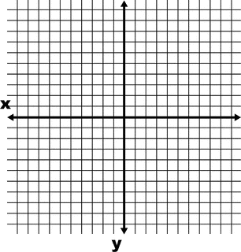
9. Given the equation: y = x² – 7x + 10
- Find the vertex and axis of symmetry.

- Find the solutions by graphing. (Hint: Find the vertex and make a table of values.)

10. Nick’s height in meters above the water t seconds after diving from a diving board into a pool can be modeled by
h = -4.9t² + 4.9t + 5.

a.) What is Nick’s maximum height above the water?
b.) How long did it take Nick to reach his maximum height?

c.) How long will it take Nick to hit the water again?

- Alwyn found the discriminant of the quadratic equation 2x² – 7x – 15 and got 71. Jackie solved it and got -71. Josef solved it and got the correct answer.
    - Why is Alwyn’s answer incorrect?

    - What was Jackie’s error?

    - What did Josef find as the Discriminant?

    - Based on Josef’s answer, describe the number and type of roots of the equation.

    - Find the x-intercepts of the equation (use the Quadratic Formula).

- A ball is thrown into the air with the following trajectory in which h is height in feet and t is time in seconds: h(t) = -2t² +4t + 7.
a. How high is the ball after 3 seconds?

b. What was the initial height of the object?

c.) SKETCH the graph of the function on the grid provided and label:
- Maximum height
- When the ball hits the ground
- The starting point of the ball

