UNIT 3 STUDY GUIDE
Parent Functions: Fill in the table, identify the domain and range, and draw each graph.
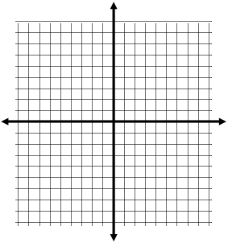  Absolute Value: f(x) = |x|  X Y  -2  -1  0  1  2  Domain: _____________  Range: _____________  Even or Odd: _____________ | Square Root: f(x) = $\sqrt{x}$  X Y  0  1  2  3  4  Domain: _____________  Range: _____________  Even or Odd: _____________
Quadratic: f(x) = x²  X Y  -2  -1  0  1  2  Domain: _____________  Range: _____________  Even or Odd: _____________ | Cubic: f(x) = x³  X Y  -2  -1  0  1  2  Domain: _____________  Range: _____________  Even or Odd: _____________
Cubed Root: f(x) = $\sqrt[3]{x}$
X | Y
-8
-1
0
1
8
Domain: _____________
Range: _____________
Even or Odd: _____________

Transformations
- y = $\sqrt[3]{x+4}-1$ | - y = –|x–1|+2 | - y = x³ – 3 | - y = (x + 2)² + 2 | - y = –$\sqrt{x+2}+2$
Below, describe the transformations above using complete sentences.

Function Operations
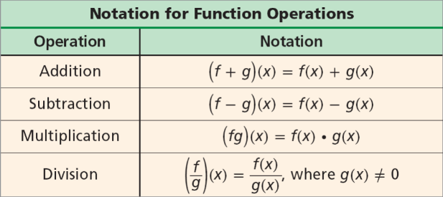
- If f(x) = 4x² + 1, and g(x) = 5x³, find (f•g)(x).

- If f(x) = 9x + 4 and g(x) = -17x – 2, find (f+g)(x).

- If f(x) = 5x – 3 and g(x) = 2x³ – 3x, find (f•g )(4).

- If (h – g)(x) = 33x² – 4x – 2 and g(x) = x + 1, find h(x).

Piecewise Functions
1.
4, if x < 2
f(x) = x², if 2 ≤ x ≤ 6
3x – 18, if x > 6

Continuous or Discontinuous?

- f(-3) b) f(4) c) f(11)

2.
2x + 5, if x < -3
f(x) = x, if -3 ≤ x < 2
-6, if x ≥ 2

Continuous or Discontinuous?
- f(-2) b) f(0) c) f(8)

3. When a diabetic takes long-acting insulin, the insulin reaches its peak effect on the blood sugar level in about three hours. This effect remains fairly constant for 5 hours, then declines, and is very low until the next injection. In a typical patient, the level of insulin might be modeled by the following function.$f \left(t\right)= \left\{\begin{aligned}30t+100 if 0 ≤t ≤3 \\ 210 if 3<t ≤8 \\ -70t+870 if 8<t ≤12 \\ 50 if 12<t ≤24\end{aligned}\right.$

Here, represents the blood sugar level at time t hours after the time of the injection. If a patient takes insulin at 6 am, find the blood sugar level at each of the following times.
a. 8 am b. 12 pm c. 4 pm d. 6 pm

