**#1 DISTANCE & MIDPOINT FORMULA**

**Distance Formula:** The **distance** between two points is: 

**Midpoint Formula:** The **midpoint** (middle) of the line between two points is: 

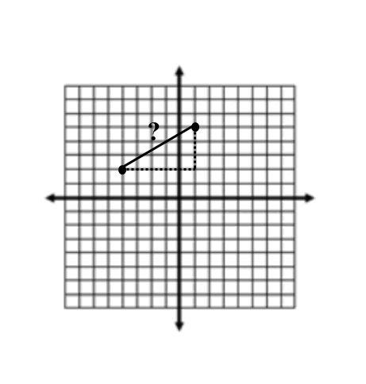1.) Find the distance between the two points. 2.) Find the midpoint of P(-3, -2) and Q(5, -2).

3.) Find the distance between the two points. P(7,0) and Q(8,0) 4.) Find the midpoint of the two points. P(-3,-4) and Q(5,-5)

5.) For  the coordinates of P and M (the midpoint) are 6.) Find the distance and midpoint for the following

given. Find the coordinates for Q. P(-2,3) and M (5,1) coordinates . P(7.6 ,10.1) and Q(4.6 ,3.1)

**#2 TRANSLATIONS** *Directions:*  *Graph each figure and the image under the given translation. Name the new coordinates.*

1.  with vertices L(-3, -1),

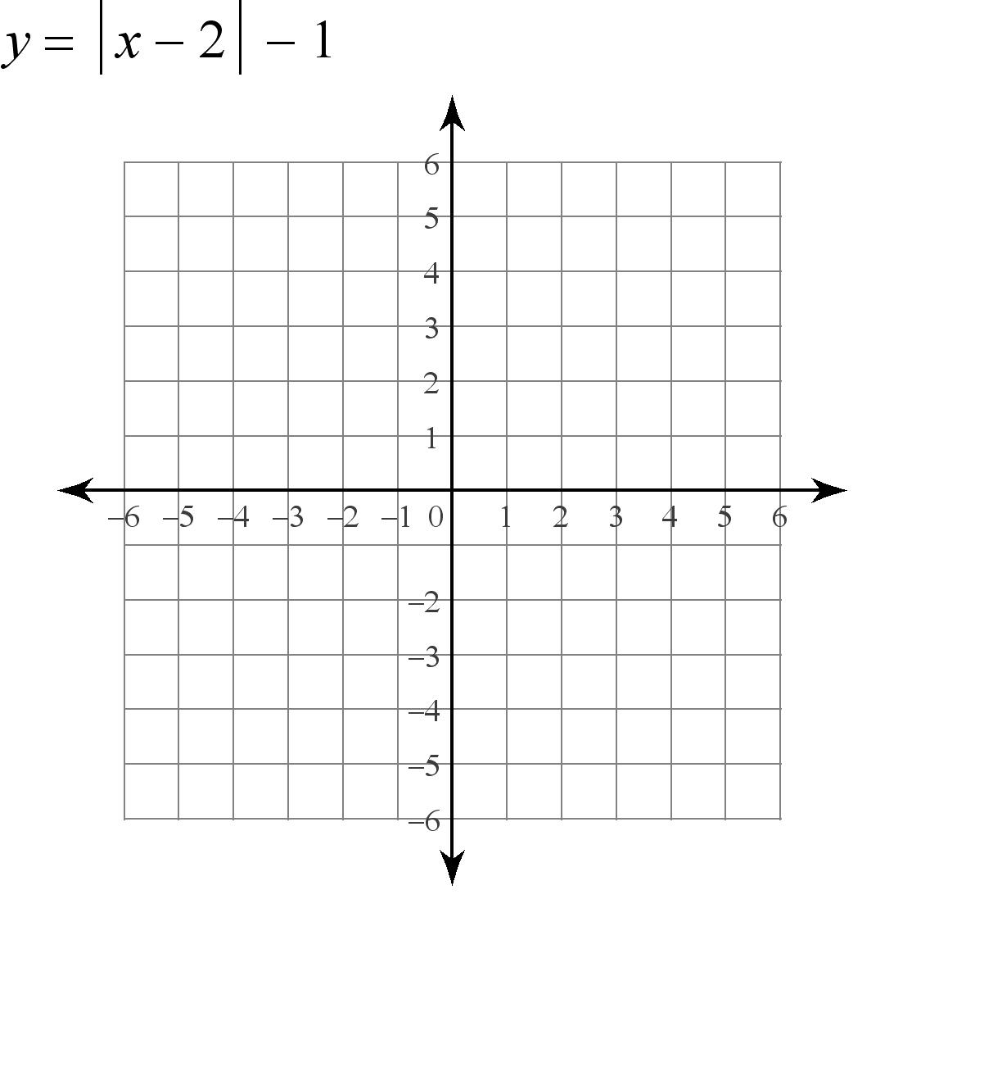I(-1, 4), and P(2, 2) under the translation .

2. Quadrilateral DUCK with vertices D(2,2), U(4, 1), C(3, -2), and K(0,-1) under the translation .

3.  with vertices R(-4, -1), S(-1, 3), and T(-1, 1) under the translation 

L’_____

I’_____

P’_____

D’_____

U’_____

C’_____

K’_____R’_____

S’_____

T’_____

4. Quadrilateral BAND with vertices B(-3, -3), A(2, -3), N(5, 1), and D(1, 1) under the translation .



5. Pentagon MOUSE with vertices M  
(-1, -2), O(2, -1), U(5, -2), S(4, -4), and E(1, -4) under the translation .



6. Quadrilateral MATH with vertices M(4, 1), A(2, 4), T(0,6), and H(1,2) under the translation .

B’_____

A’_____

N’_____

D’_____

M’_____

O’_____

U’_____

S’_____  
E’_____

M’_____

A’_____

T’_____  
H’____

**#3 DILATIONS** *Directions: Choose 6 of the following. Use the graph paper at the end of this packet to draw your graphs.*

1. After a dilation, (-35, 0) is the image of (-5, 0). What are the coordinates of the image of (-7, 7) after the same dilation?

2. What is the image of the point (-8, -24) after a dilation of ?

3. What is the image of the point (5, 3) after a dilation of 8?

4. After a dilation, (5, 0) is the image of (45, 0). What are the coordinates of the image of (18, 72) after the same dilation?

5. What is the image of triangle TGI with T(2, 9), G(-3, 0) and I(4, 8) after a dilation of 5? Is this an enlargement or reduction?

6. What is the image of triangle KCN with K(-12, 0), C(0, 54) and N(24, 42) after a dilation of ? Is this an enlargement or reduction?

7. The translation of triangle IPO with I(-36, 36), P(-20, 0) and O(40, 28) after a dilation is I’(-9, 9), P’(-5, 0) and O’(10, 7). What is the scale factor of the dilation?

8. The translation of triangle IFJ with I(9, -2), F(-5, -10) and J(0, -11) after a dilation is I’(18, -4), F’(-10, -20) and J’(0, -22). What is the scale factor of the dilation?

9. After a dilation, (7, -11) is the image of (49, -77). What are the coordinates of the image of (-70, 28) after the same dilation?

10. The translation of triangle STO with S(72, 72), T(9, 108) and O(-108, -27) after a dilation is S’(8, 8), T’(1, 12) and O’(-12, -3). What is the scale factor of the dilation?

**#4 REFLECTIONS:**  *Directions:*  *Graph each figure and its image under the given reflection. Find the coordinates of the vertices of each image. Label all points.*

1) ΔEFG if E(-1, 2), F(2, 4) and G(2, -4) reflected over the y-axis.

2) ΔPQR if P(1, 2), Q(4, 4) and R(2, -3) reflected over the x-axis.

3) ΔABC with vertices A(2,3), B(4, 1), and C(2, 1) reflected over the x-axis.

E’_____ P’_____ A’_____

F’_____ Q’_____ B’_____

G’_____ R’_____ C’_____

4) ΔABC if A(0, 3), B(1, -1), and C(-2, -2) For problems 1-4, examine how the coordinates for each   
reflected over the line y-axis. point changed after the reflection? Which were the same?  
 Which were different? What pattern did you see?

A’ _______  
B’ _______

C’ _______ Write a rule for a reflection over the x-axis and one for over the y-axis:

Over x-axis: (x,y) 🡪 ( ___, ___) Over y-axis: (x,y)🡪 (___, ___)

5) ΔBEL if B(-2, 3), E(2, 4), 6) Quadrilateral VWXY if V(0, -1), 7) Parallelogram TINK if   
and L(3, 1) reflected over the W(1, 1), X(4, -1), and Y(1, -5) T(-1, 1), I(3, 0), N(4, -3) and   
line . reflected over the line . K(0,-2) reflected over.



B’ _____ V’ _____ T’_____

E’ _____ W’_____ I’ _____

L’ _____ X’ _____ N’ _____

Y’______ K’______

What pattern did you see from problems 5 – 7? How did the coordinates change in this case?

Using words, write a rule for how to find the coordinates of the image of a reflection over the line . (x,y) 🡪 ( ____, ____)

8) Square SQUR if S(1, 2), Q(2, 0), 9) Quadrilateral MATH if M(1, 4), 10.)Triangle CAR if C(-6,2),   
U(0, -1), R(-1, 1) reflected over A(-1, 2), T(2, 0) and H(4, 0) A(-2,1), and R (-3,5) reflected  
the line . reflected over . over the line 

S’_____ M’_____ C’ ____

Q’_____ A’_____ A’_____

U’_____ T’_____ R’ _____

R’_____ H’_____

11. Triangle QRS if Q(3,4), R(4,3), What did you notice from the previous three problems? Could you find a  
and S(1,1) reflected over the line pattern? How did the coordinates change? Could you have written any  
. of them as a reflection over the x or y axis and then a translation?

Q’____ How would that look?

R’ ____

S’_____

12. Square SQUR if S(1, 2), Q(2, 0), U(0, -1), R(-1, 1) reflected 13. Quadrilateral MATH if M(1, 4), A(-1, 2), T(2, 0) and H(4,   
over the y-axis and translated by the rule(x,y) 🡪 (x+2, y). 0) reflected over the x-axis and translated by the rule (x,y) 🡪 (x,y+4)

S’’ _____ M’’______

Q ‘’_____ A’’______

U’’______ T’’______

R’’ ______ H’’______

Examine the transformation from 12 & 13. How do they relate to the image from h & i? Write a rule for how a reflection over a line like x=a or y=b could be written as a reflection over the x or y axis and then a translation.

**#5 ROTATIONS** *Directions: For #1-4, draw the triangle after each transformation and give the coordinates of A’, B’ and C’.*

|  |  |
| --- | --- |
| 1. Rotate the triangle 90° counterclockwise about the origin.    A  B  C | 2. Rotate the triangle 270° counterclockwise about the origin.    A  B  C |
| 3. Rotate the triangle 180° counterclockwise about the origin.    A  B  C | 4. Rotate the triangle 90° clockwise about the origin.    A  B  C |

5. Give the coordinates of D(-2, -4) after a 270° counterclockwise rotation about the origin.

6. Give the coordinates of E(-4, 5) after a 180° counterclockwise rotation about the origin.

**#6 COMPOSITIONS OF TRANSFORMATIONS** *Directions: draw the triangle after each transformation and give the coordinates of A", B" and C".*

|  |  |
| --- | --- |
| 1. Translate the triangle down 1 unit and left 1 unit. Then reflect the new triangle over the x-axis.    A  B  C | 2. Translate the triangle 1 unit right. Then rotate the new triangle 270° clockwise about the origin.    A  B  C |
| 3. Rotate the triangle 90° counterclockwise about the origin. Then translate the new triangle right 4 units and 5 units down.    A  B  C | 4. Translate the triangle 6 units down. Then reflect the new triangle across the y-axis.    A  B  C |