**Unit 5 Study Guide**

**TRIANGLE CONGRUENCE:** On looseleaf, write a proof for each of the following:

1. 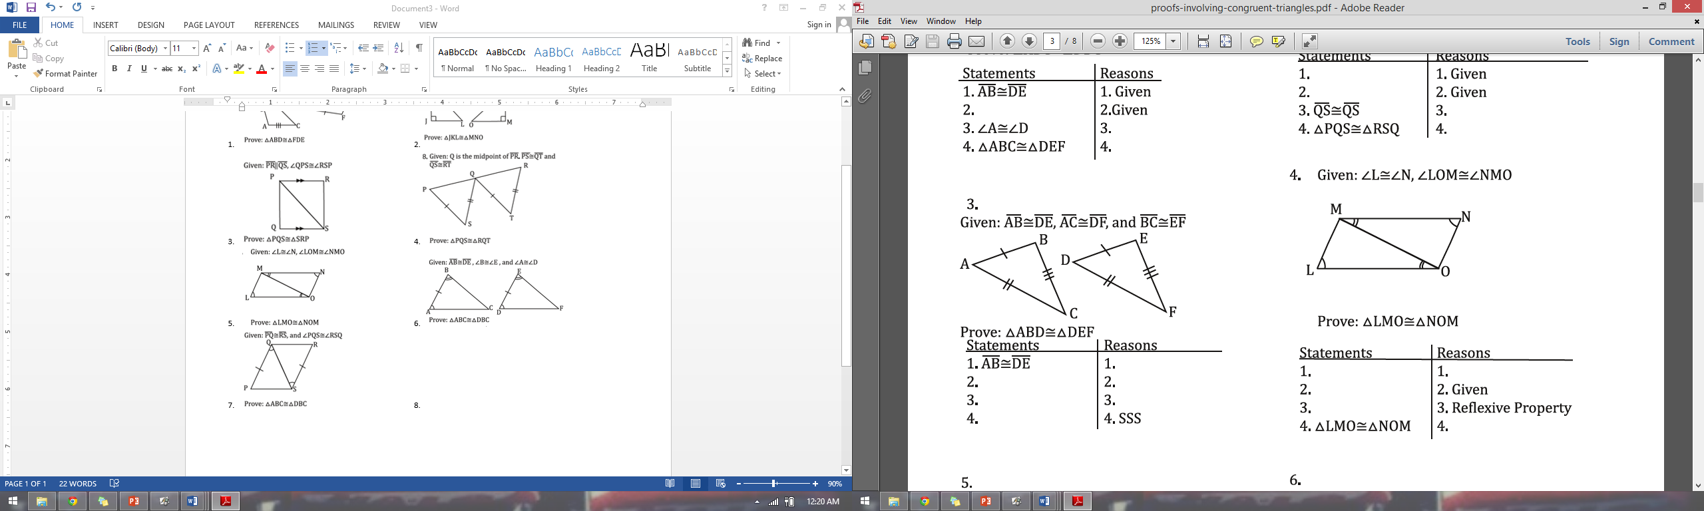 2. 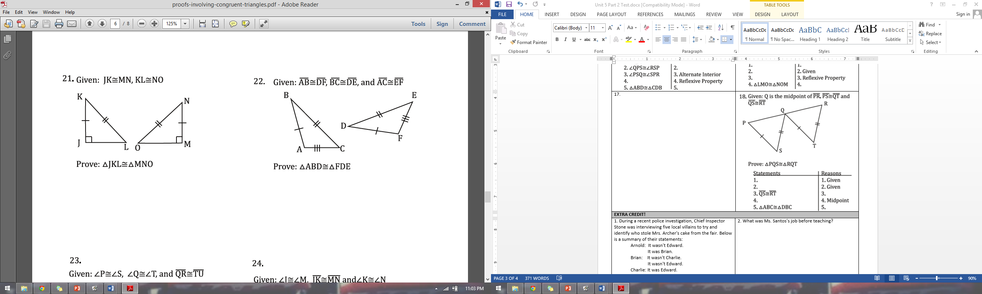
2. 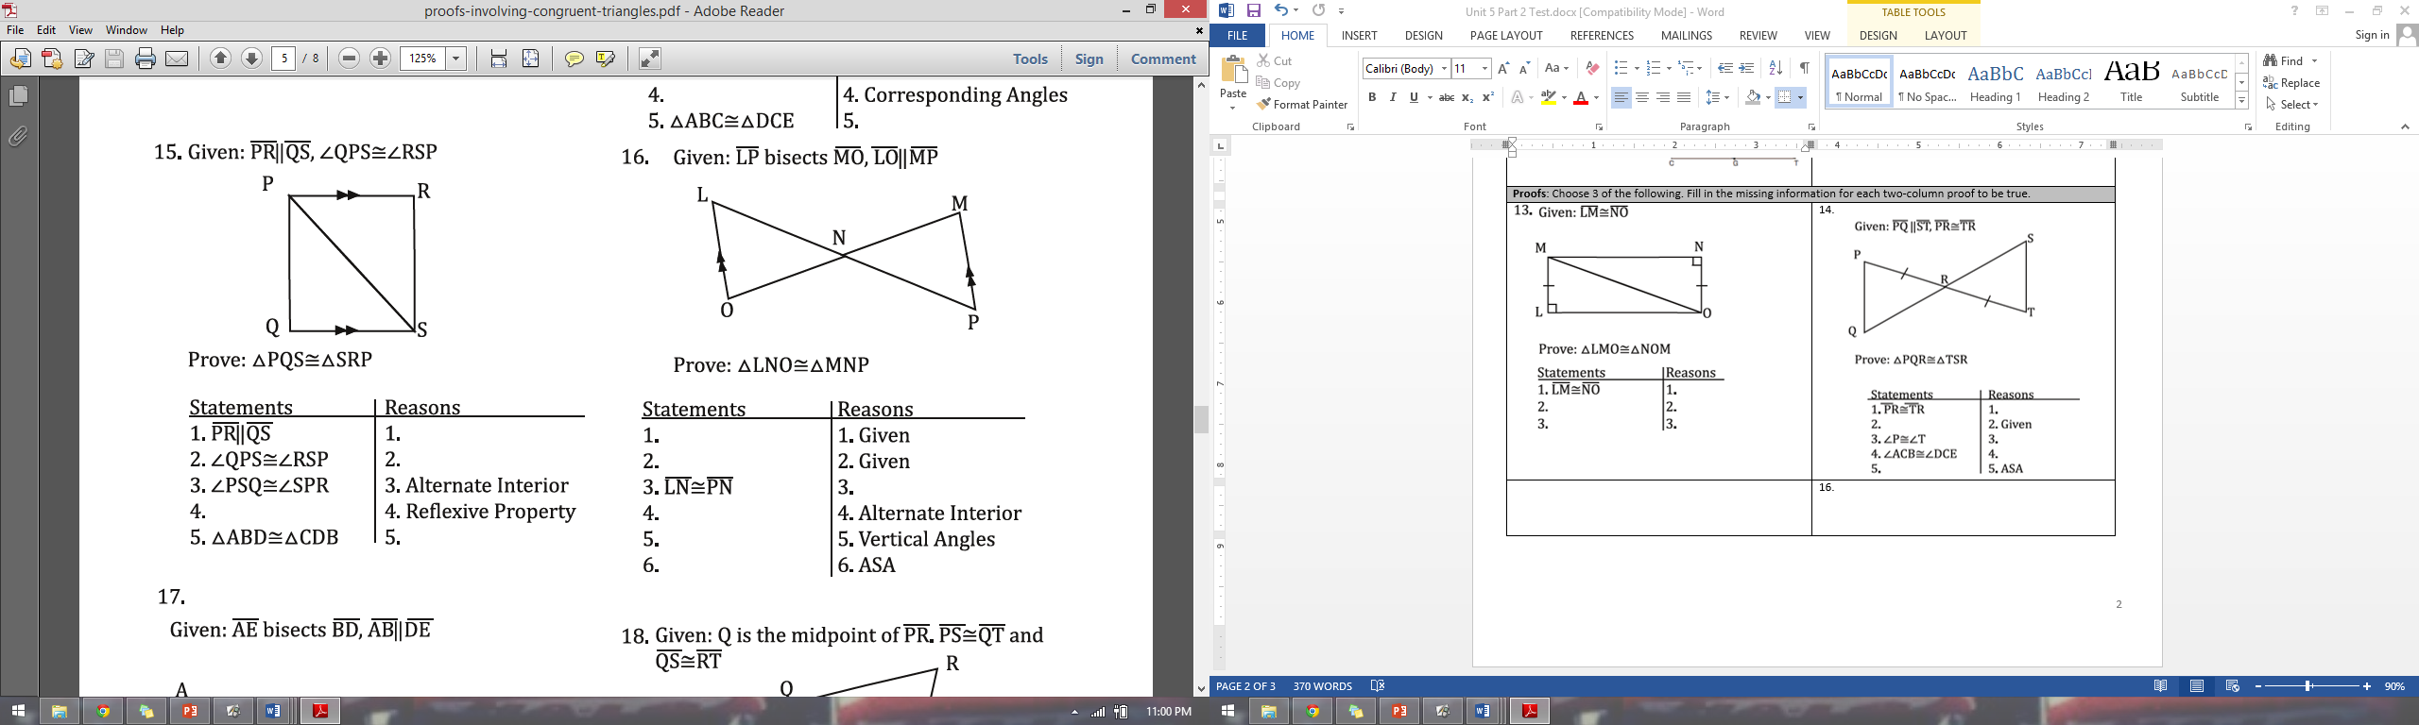 4. 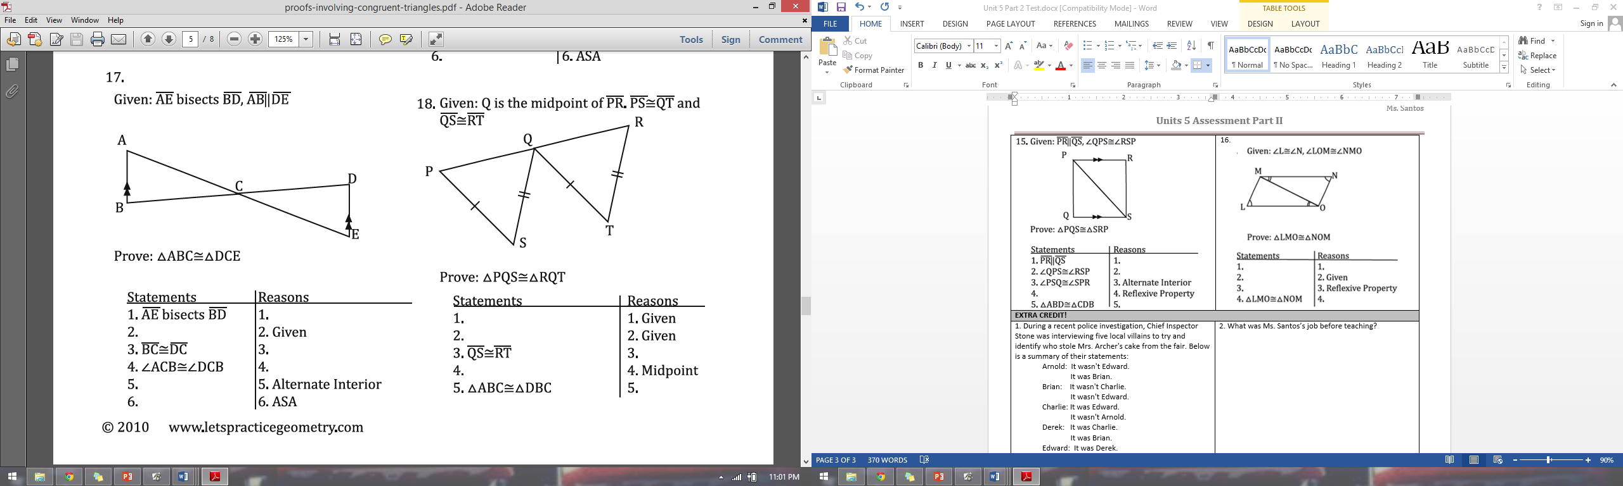
3. 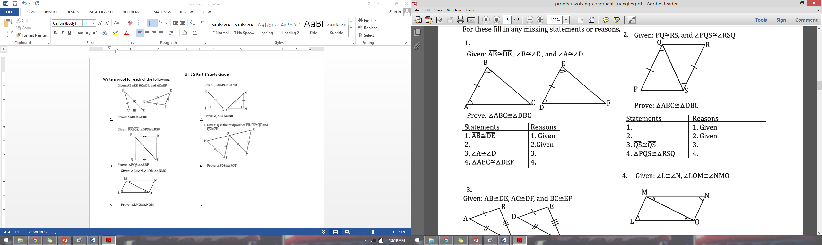 6. 
4. If AD = 3y + 5 and BC 5y - 1, what must the value of y be to prove ΔAED $≅$ ΔCEB by the SSS Postulate?

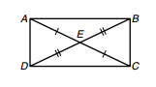

**TRIANGLE SUM/ISOSCELES TRIANGLE THEOREM**

1. If If , , and m∠CDE = 110o, what is the measure of ?

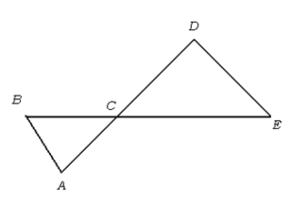

1. Find the value of x and the measure of each angle. 11. Find the measure of x.

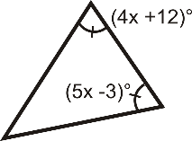 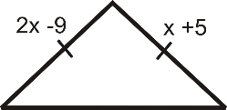

1. Find the value of x.

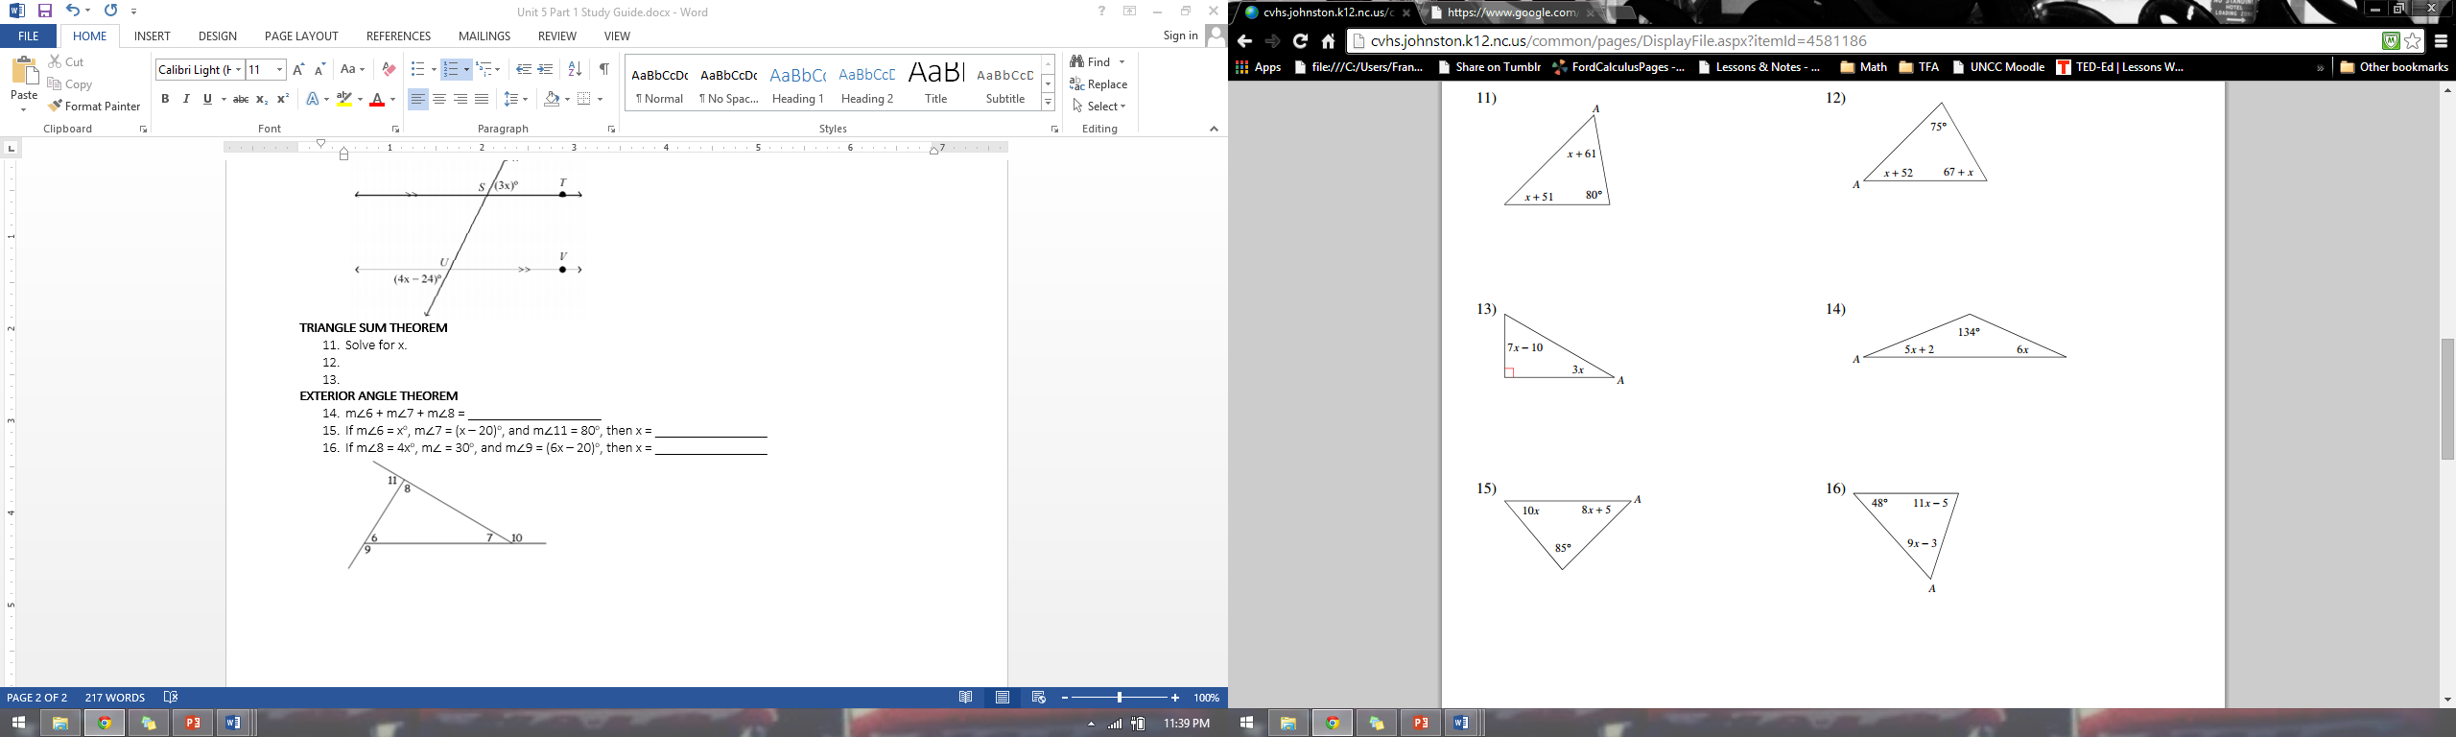

**ANGLE ADDITION POSTULATE**

1. m∠ABC = 17x + 8, m∠ABK = 42o, and m∠KBC = 12x – 4. Find m∠ABC.

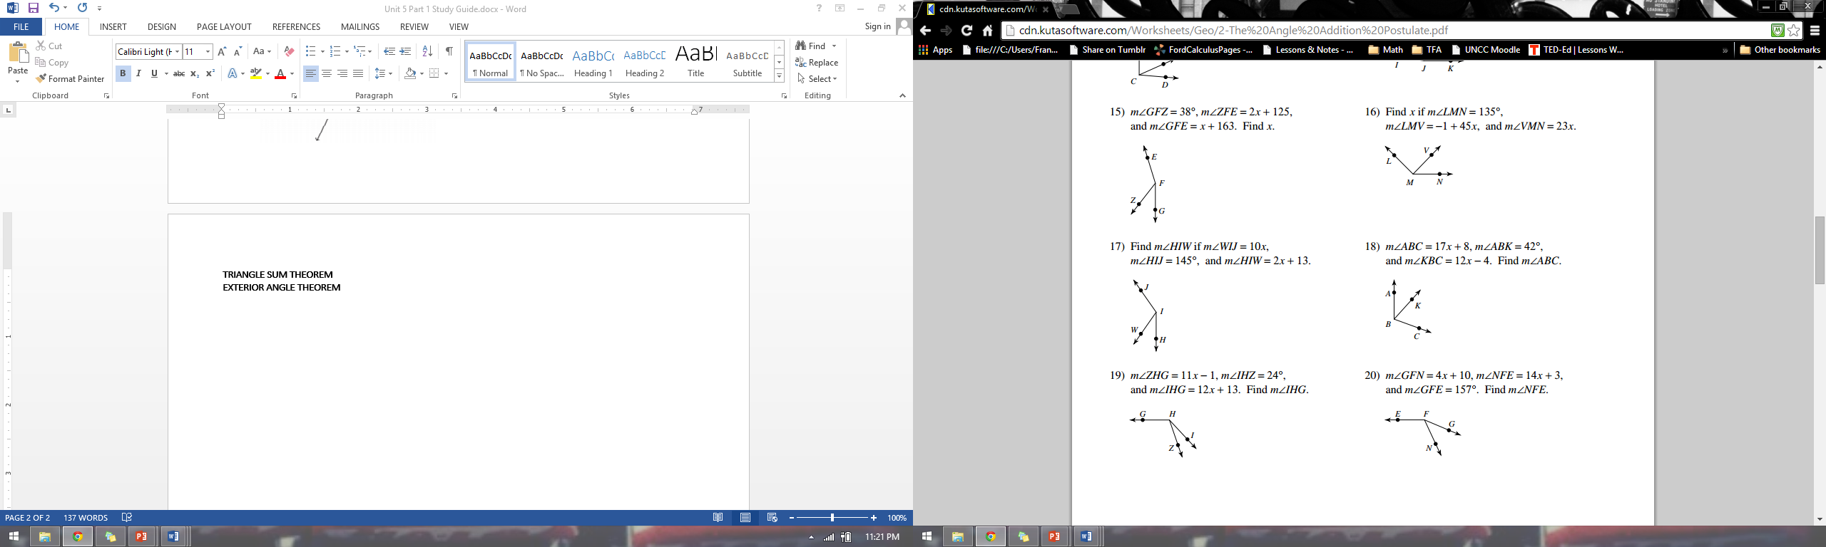

1. m∠GFN = 4x + 10, m∠NFE = 14x + 3, and m∠GFE = 157o. Find m∠NFE.



**ANGLE RELATIONSHIPS & TYPES OF ANGLES**

Use the diagram below to answer the following.

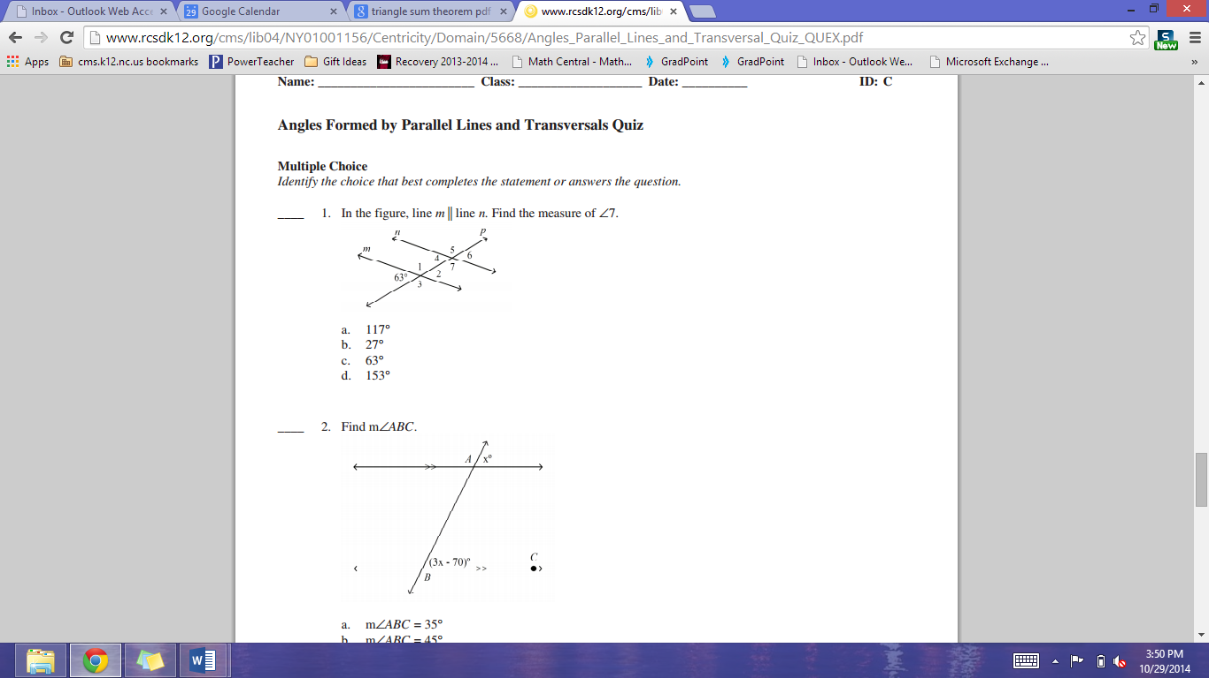

1. Define the following, and use the diagram to identify an example of each.
   1. Corresponding Angles
   2. Alternate Interior Angles
   3. Alternate Exterior Angles
   4. Consecutive Interior Angles
2. What is the measure of ∠7? Justify your answer.
3. What is the measure of ∠3? Justify your answer.
4. What is the measure of ∠2? Justify your answer.

**EXTERIOR ANGLE THEOREM**

Use the diagram below to answer the following.

1. m∠6 + m∠7 + m∠8 = ____________
2. If m∠6 = xo, m∠7 = (x – 20)o, and m∠11 = 80o, then x = ____________
3. If m∠8 = 4xo, m∠7 = 30o, and m∠9 = (6x – 20)o, then x = ____________

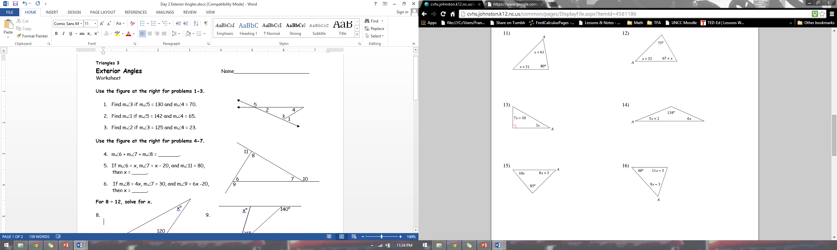

**MIDSEGMENT THEOREM**

1. Use ∆GHJ, where A, B, and C are midpoints of the sides. 23. In the diagram below of ΔACT, D is the midpoint   
   If AB = 2x+8 and GJ = 3x+24, what is AB? of AC, O is the midpoint of AT, and G is the midpoint

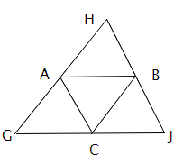of CT. If AC = 20, AT = 36, and CT = 44, what is the perimeter of parallelogram CDOG?

