**#2 Trigonometric Ratios – Sides** *Directions: Answer all of the following questions in order, to come up with your final answer for this problem-based task.*

You are a firefighter on call at a burning building. Your colleagues are on the roof preparing to help put out the blaze by entering the building through the third-floor window. They need you to find the distance from the roof to the windowsill and then determine if the firefighters on the ground are close enough to the building for the water to reach the flames through the window on the third floor.

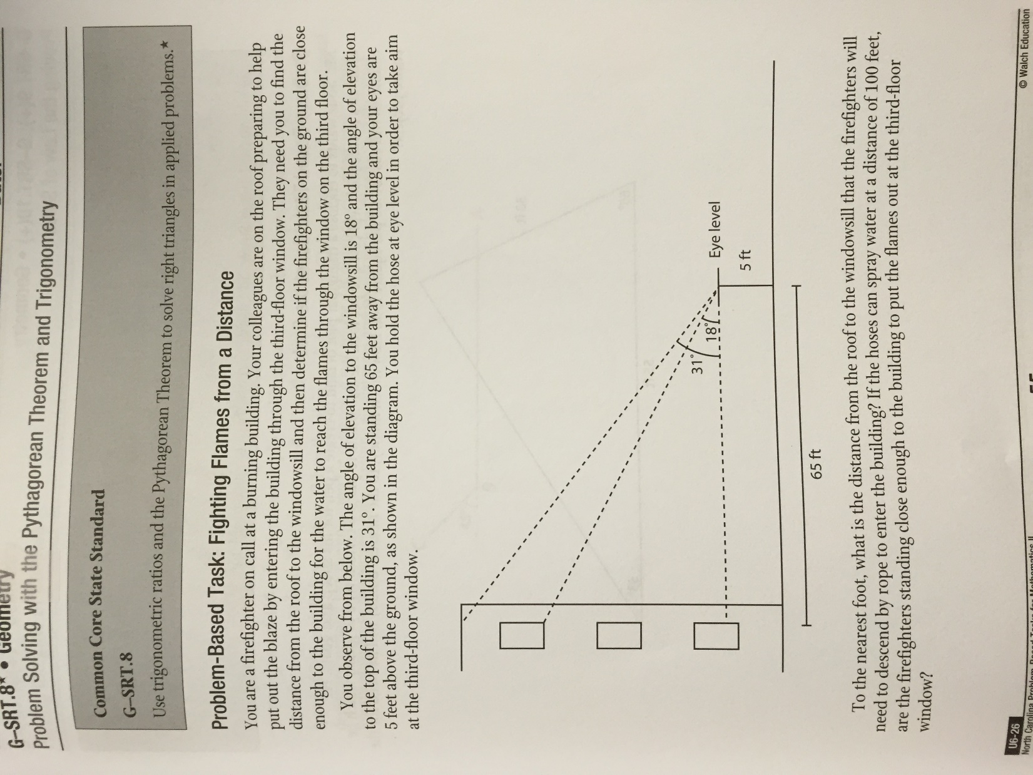 You observe from below. The angle of elevation to the windowsill is 18o and the angle of the elevation to the top of the building is 31o. You are standing 65 feet away from the building and your eyes are 5 feet above the ground, as shown in the diagram. You hold the hose at eye level in order to take aim at the third-floor window.

To the nearest foot, what is the distance from the roof to the windowsill that the firefighters will need to descend by rope to enter the building? If the hoses can spray water at a distance of 100 feet, are the firefighters standing close enough to the building to put the flames out at the third-floor window?

1. In order to determine the distance from the windowsill to the roof, what other information do you need to find first?
2. What is the vertical height from the roof to your eye level? Sketch the triangle that provides the information necessary to answer the question.
3. What is the vertical height from the windowsill to your eye level?
4. What is the distance from the roof to the third-floor windowsill?
5. How can you use the information you’ve already found to determine the distance the water has to travel?
6. What distance does the water have to travel to reach the window?
7. Are the firefighters on the ground close enough to the building?

**#3 Trigonometric Ratios – Angles** *Directions: Answer all of the following questions in order, to come up with your final answer for this problem-based task.*

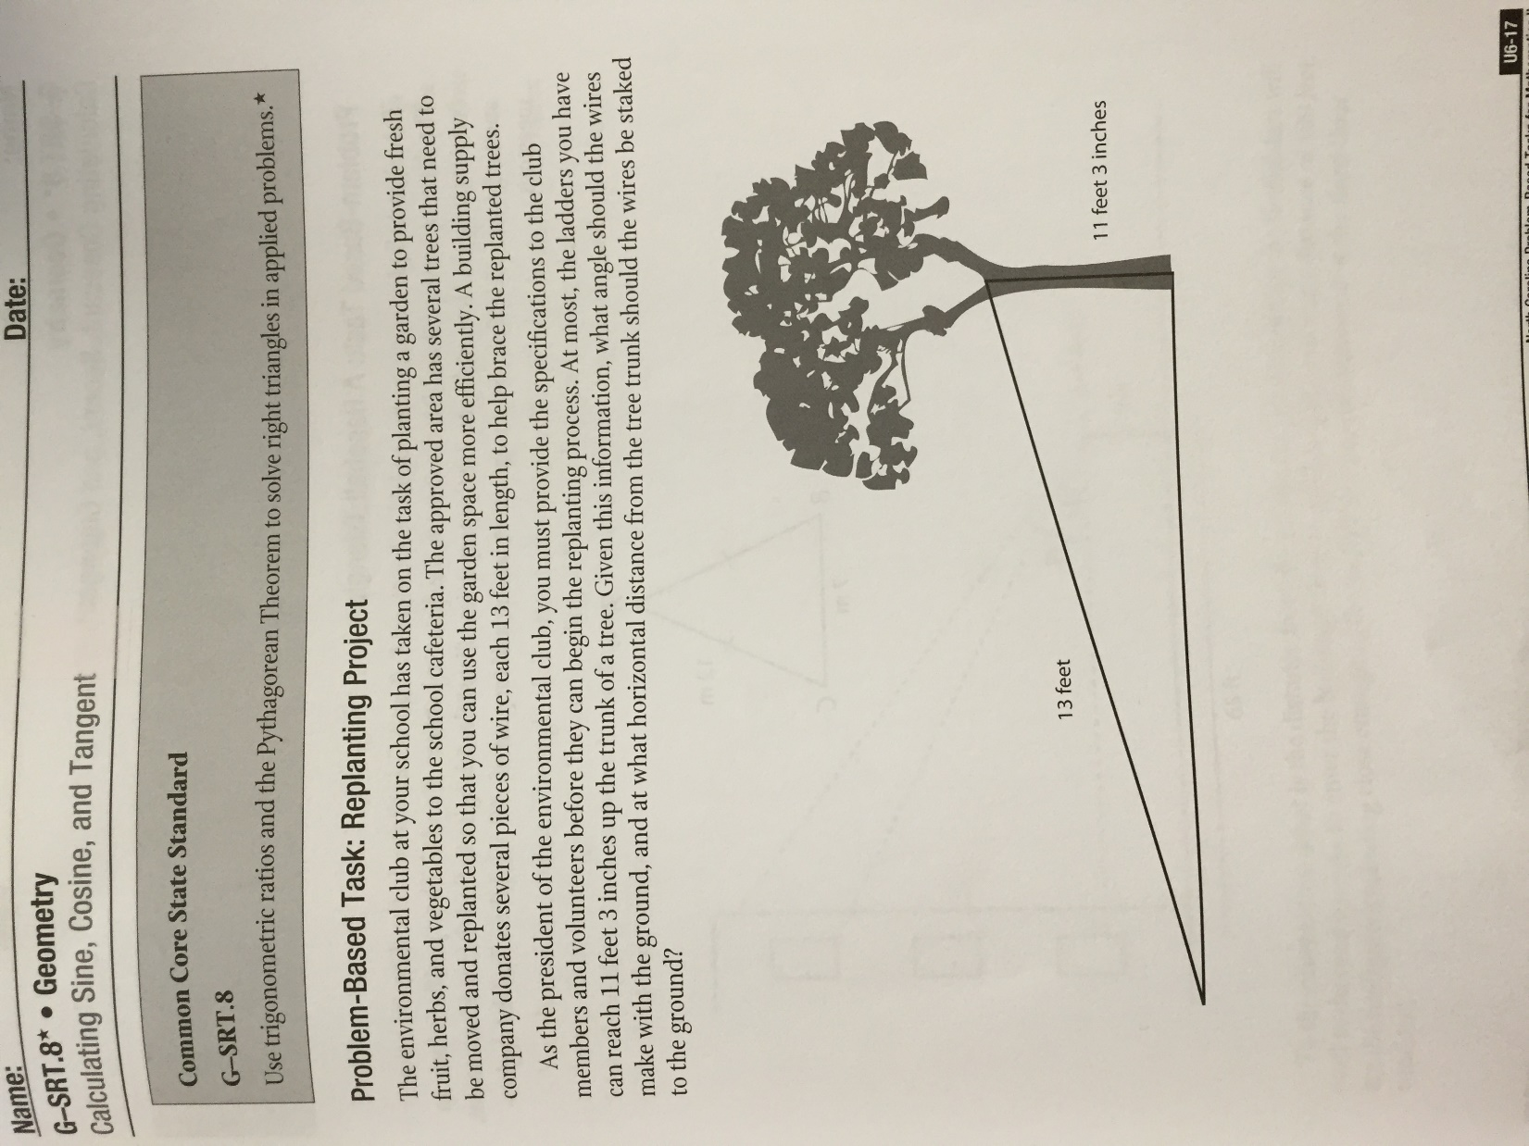The environmental club at your school has taken on the task of planting a garden to provide fresh fruit, herbs, and vegetables to the school cafeteria. The approved area has several trees that need to be moved and replanted so that you can use the garden space more efficiently. A building supply company donates several pieces of wire, each 13 feet in length, to help brace the replanted trees.

As the president of the environmental club, you must provide the specifications to the club members and volunteers before they can begin the replanting process. At most, the ladders you have can reach 11 feet 3 inches up the trunk of a tree. Given this information, what angle should the wires make with the ground, and at what horizontal distance from the tree trunk should the wires be staked to the ground?

1. What is the maximum height, in inches, each wire can be secured to a tree?
2. What is the length of each wire in inches?
3. Based on the given information, which trigonometric function is required to find the angle at which each wire should be staked to the ground? What is the angle measure?
4. What right triangle property (trigonometric ratio) should you use to most accurately find the distance from the trunk of the tree to the spot where the wire will be staked to the ground?
5. What is the distance, in inches, from the trunk of the tree to the spot where the wire will be staked to the ground?

**#4 Special Right Triangles** *Directions: If your file number is even, only do the evens. If your file number is odd, only do the odds.*

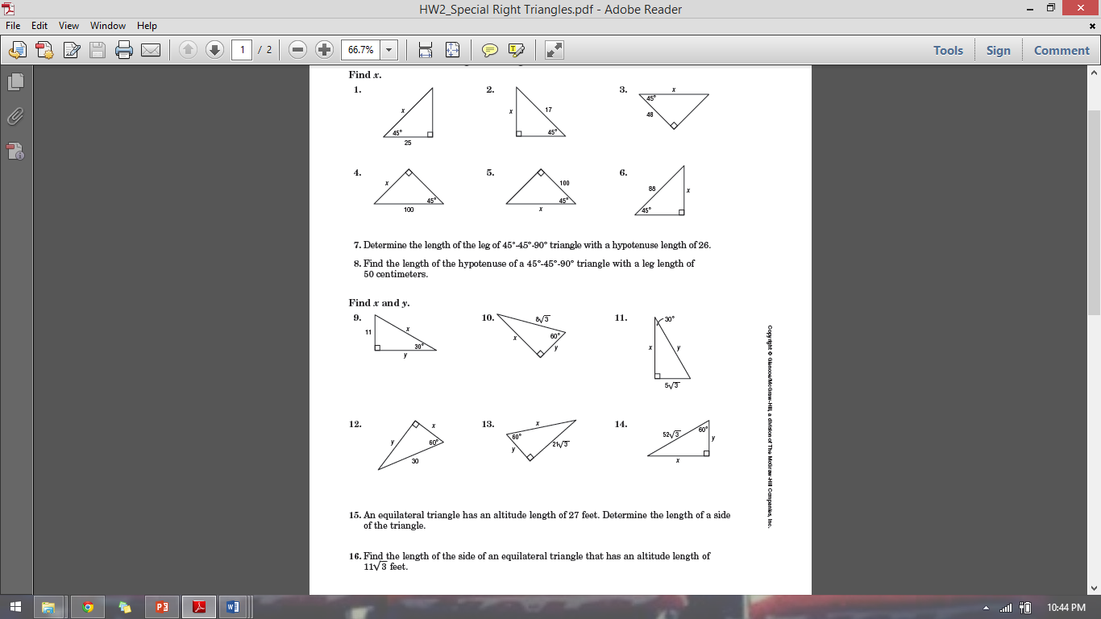

**#5 Law of Sines & #6 Law of Cosines** *Directions: If your file number is even, only do the evens. If your file number is odd, do the odds.*

1. 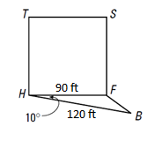 A baseball infield is determined by a square with sides 90 ft long. In the diagram, home plate is  
   *H* and first base is *F*. Suppose the first baseman ran in a straight line from *F* to catch a pop-up at   
   *B*, 120 ft from home plate. If the measure of ∠*FHB* is 10°, how far did the first baseman run?

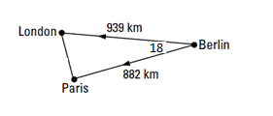

1. Two airplanes leave Berlin, one heading straight for London and the other   
   straight for Paris. The angle formed is 18 degrees. Use the Law of Cosines  
   to estimate the distance from London to Paris.
2. Find *BC* 4.) Find *TA* 5.) Find DE







6.) Find *AB* 7.) Find m∠*G*  

8.) Some students in Geometry are assigned the task of measuring the   
 distance between two trees separated by a swamp. The students determine   
 that the angle formed by tree *A*, a dry point *C*, and tree *B* is 27°. They also   
 know that m∠*ABC* is 85°. If *AC* is 150 ft, how far apart are the trees?



9.) Two lookout towers, *L* and *M*, are 50 kilometers apart. The ranger in Tower *L* sees a fire at point *C*   
 such that m∠*CLM* = 40°. The ranger in Tower *M* sees the same fire such that m∠*CML* = 65°. How far   
 is the fire from Tower *L*?

10.) Find *JM* 11.) Find *DF* 12.) Find *PA*







13.) Find *BC* 14.) Find *DE* 15.) Find *NO*







**#7 Area of a Triangle** *Find the area of each triangle using the formula learned in class. Round your answers to the nearest tenth.* 