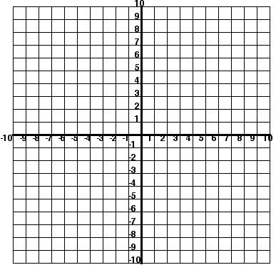
#1 Equations of Circles: Answer Problem 1 in its entirety. Then choose 1 problem from #2-4 and 1 problem from #5-7 of the remaining problems to complete. Additional problems may be completed for extra points.
- APPLICATION PROBLEM: Find the circumference and area of the circle whose equation is (x – 9)² + (y – 3)² = 64. Leave your answers in terms of pi. Include in your answer the following: What essential information do you need? What formulas will you use?

- Given the equation (x – 5)² + (y – 2)² = 36, find its center 3. Given the equation (x + 1)² + y² = 121, find its
and radius, then graph circle. center and radius, then graph circle.

- Given the equation (x + 3)² + (y + 1)² = 49, find its center 5. Find the center and radius of a circle if the
and radius, then graph circle. endpoints of the diameter are (0,0) and (6,8).

- Find the center and radius of a circle if the 7. Find the center and radius of a circle if the
endpoints of a diameter are (-2,3) and (4,-5). endpoints of a diameter are (0,-5) and (-7,-3).

#2 Volume & Surface Area: Find the volume of each figure. Only find the surface area if indicated. Round your answer to the nearest tenth. Be sure to label your answers with indicated unit of measurement.(Use Π = 3.14)
Surface Area = _____________ Surface Area = _____________ Surface Area = _____________

Surface Area = _____________ Surface Area = _____________ Surface Area = _____________

#3 Cross Sections: Match the descriptions on the left with the correct two- or three-dimensional figure on the right, by drawing lines connecting the pairs that go together. Then choose two problems from #7-10 to solve.
- The vertical cross section of a cone 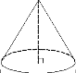 a. sphere
- The 3D shape formed by rotating a circle b. square
- The vertical cross section of a cylinder 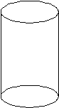 c. triangle
- The 3D shape formed by rotating a rectangle d. cylinder
- The horizontal cross section of a pyramid 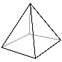 e. cone
- The 3D shape formed by rotating a triangle by one vertex f. rectangle

- A circle has a radius of 15cm. what is the volume of the sphere made by rotating this circle?

- Given a cylinder with radius 7 inches and height 10 inches, find the area of a cross section that is parallel to its base.

- Given a cylinder with height 60mm and radius 20mm, find the area of the rectangle formed by a perpendicular cross-section right down the cylinder’s center.

- If an equilateral triangle with perimeter 24cm is rotated, find the volume of the cone that is formed.

#4 Inverse Variation & Density: Use the inverse variation formula to solve the following. Be sure to set up two equations and solve for the constant first!
- The time, t, required to do a job varies inversely with the number of people, p, working on the job. If it takes 6 hours for 8 workers to complete a job. How long will it take if there are 9 workers?

- The loudness, L, of sound measured in decibels, dB, is inversely proportional to the square of the distance, d, in feet from the sound source. If a person is 15 feet from a leaf blower, the sound is 100 db. How loud is the leaf blower if someone is 45 feet away? Round to the nearest tenth.

- The volume of gas in a container at a constant temperature varies inversely as the pressure. If the volume is 32 cubic centimeters at a pressure of 8 pounds, find the pressure when the volume is 60 cubic centimeters.

- The volume V of a gas varies inversely as the pressure P on it. If the volume is 240 cm³ under pressure of 30 kg/cm², what pressure has to be applied to have a volume of 160 cm³?

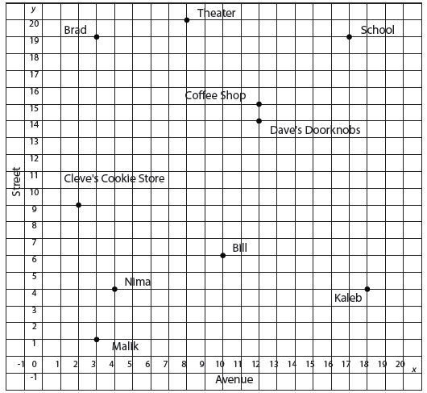
#5 Partitioning Directed Line Segments: Use the map and the information given to solve each partitioning directed line segment problem below.

- Luis works at a theater on 8th Avenue and 20th Street. Kaleb lives at the corner of 18th Avenue and 4th Street. What is a possible location that is midway between them?

- Nima lives at the corner of 4th Avenue and 4th Street. Bill lives at the corner of 10th Avenue and 6th Street. Their favorite bakery is located midway between them. What is one possible of the bakery?

- Cleve’s Cookie Store is located at the corner of 2nd Avenue and 9th Street. Dave’s Doorknobs is located at the corner of 12th Avenue and 14th Street. Located 1/5 of the distance from Cleve’s Cookie Store is the post office. Where is the post office?

- Malik and Brad both live on 3rd Avenue. Malik lives at the corner of 1st Street, and Brad lives at the corner of 19th Street. 2/3 the distance from Malik’s apartment to Brad’s apartment is a market. Where is the market?

- The main entrance to the high school is located at the corner of 17th Avenue and 19th Street. On his way from school to the bank, Luis stops at the coffee shop located at 12th Avenue and 15th Street. The coffee shop is the midpoint of this trip. What is the location of the bank?

